What is ocean acidification?
Ocean acidification is a term used to describe the changes in the chemistry of the world's seas, primarily as a result of burning fossil fuels.
Marine scientists are concerned that changes to the oceans' pH levels will have severe consequences for marine wildlife and ecosystems.

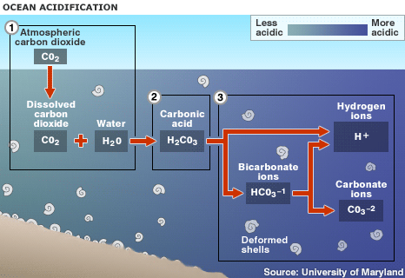
1. Up to one half of the carbon dioxide (CO2) released by burning fossil fuels over the past 200 years has been absorbed by the world's oceans 2. Absorbed CO2 in seawater (H2O) forms carbonic acid (H2CO3), lowering the water's pH level and making it more acidic 3. This raises the hydrogen ion concentration in the water, and limits organisms' access to carbonate ions, which are needed to form hard parts
Since the Industrial Revolution, there has been a sharp increase in atmospheric CO2 as a result of human activity, primarily from burning fossil fuels.
THE pH SCALE Higher numbers indicate alkalis, while lower numbers signify acidic liquids:
• 13 - bleach
• 10 - soap
• 8.2 - pre-1750 oceans (average)
• 8.1 - current oceans (average)
• 7.8 - oceans in 2100 (projected average)
• 7 - pure water
• 3 - vinegar
• 0 - battery acid ( Source: NMEA )
The oceans have absorbed up to half of this excess CO2, which has resulted in changes in the chemistry of surface seawater. The CO2 in the water, which leads to the formation of carbonic acid, has caused the pH of surface oceans to fall by 0.1 units, and it is projected to fall a further 0.3-0.4 pH units by the end of the century.

The shift in the waters' chemical make-up not only increases its acidity, but reduces the availability of carbonate ions, which many creatures use to build shells and skeletons out of calcium carbonate. The decrease in available carbonate ions means that organisms, such as plankton, coral and molluscs, struggle to build or maintain their protective or supportive structures.

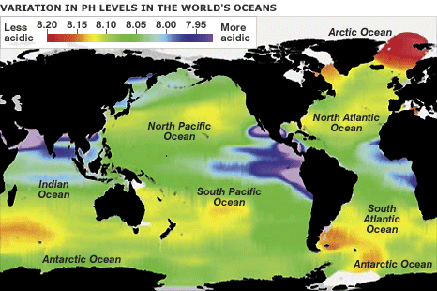
The pH of the world's oceans is not consistent across the globe. Researchers believe that areas with relatively low pH (the purple areas on the map above), such as the eastern Pacific, could be the result of the upwelling of deeper, colder, CO2-richer waters.

However, no region is expected to escape the impact of falling pH. As a result, marine biologists say that a number of species and ecosystems face an uncertain future:

Warm-water coral reefs
Evidence suggests that the calcification rates of these corals will be reduced by up to 60%, say US researchers writing in the journal Current Biology. They say a reduction of this magnitude could adversely affect reef structures, as growth depends on corals' ability to build faster than the skeleton is eroded. Weaker structures are likely to be prone to greater degrees of erosion from storms and heavy wave action.

Cold-water corals Found throughout the world's oceans, cold-water corals can provide vital habitat for several commercially important fish species. Forecasts suggest that about 70% of the corals could find themselves under threat by the end of the century.

Plankton These tiny organisms play an important role in the marine food chain. Several groups of plankton produce calcium carbonate, and could see their distribution curtailed by ocean acidification.
Scientists agree that more research is required in order to better understand the impact of oceans' falling pH on the tiny creatures. Some species, such as coccolithophores (single-celled algae), have shown a marked decrease in calcification rates when exposed to CO2-rich water. However, others species were largely unaffected.

Invertebrates Some molluscs, including mussels and oysters, are expected to be adversely affected by ocean acidification. As with other creatures, the main impact is expected to be thin or deformed shells.
Juveniles have been shown to be more susceptible than adults to limited carbonate ions, which could have long-term consequences as far as viable populations are concerned. But not all habitats suffer as a result of ocean acidification. For example, sea grasses grow better in CO2-rich waters. The grass offers a valuable feeding and spawning site for a variety of species, including a number of commercially valuable fish.

However, more research is needed to see if the local benefits from the sea grasses are not outweighed by the wider disruption to the marine food chain.
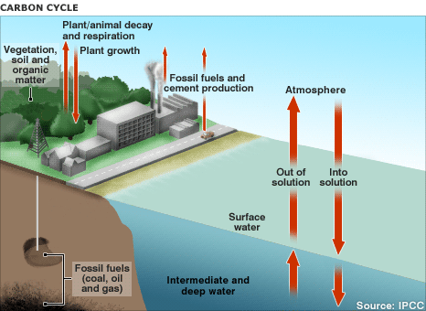

The Earth's carbon cycle, the exchange of CO2 between land, sea and air, is generally meant to be in equilibrium. However, human activities, such as burning fossil fuels and deforestation, mean that an increasing amount of CO2 is being released into the atmosphere. But not all of the unlocked CO2 remains in the atmosphere. Up to 50% of the emissions are absorbed by the ocean.

The oceans absorb carbon in two main ways - physically and biologically. Physically, CO2 dissolves into cold ocean water near the poles, and it is carried to the deep ocean by sinking currents, where it stays for hundreds of years. Over time, thermal mixing brings the water back to the surface and the ocean emits carbon dioxide into the atmosphere in tropical regions. This natural system helps pump carbon from the atmosphere into the sea for storage.

The biological absorption of CO2 involves phytoplankton, which use sunlight, water and CO2 to produce carbohydrates and oxygen. When the plankton and the sea animals that eat the plankton die, they sink to the ocean floor. A small percentage of the carbon in the creatures' remains is eventually buried and stored in the sediment.

'Feedback mechanisms'
These natural "carbon pumps" are showing signs of being disrupted, say researchers. For example, ocean acidification could reduce plankton blooms, resulting in less CO2 being absorbed from the atmosphere.
In theory, the extra CO2 in the atmosphere could lead to an acceleration in global warming, which will warm the oceans.

As a result, the warmer waters will not be able to absorb as much carbon dioxide as cooler seas. So even less CO2 is taken from the atmosphere, resulting in more of the greenhouse gas being available to warm the planet. The potential of these "feedback" mechanisms to disrupt the planet's climate system is one of the reasons why marine scientists are calling for urgent action to be taken to stabilize, and eventually reduce, emissions.

