What is driving urban gentrification?
Sep 16th 2013

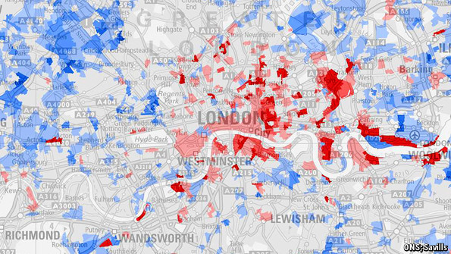
Click to enlarge
GENTRIFICATION, it turns out, has even spread to the former Communist eastern bloc. Around the railway station in Tallinn, the capital of Estonia, is a collection of wooden-slat houses built in the early 20th century. Twenty years ago, when Estonia’s murder rate was almost as high as Mexico’s is today, they were abandoned to squatters and petty criminals. But today aspirational Estonians are buying up the old houses, and bars and cafes are flourishing in the area. So if gentrification is happening in Estonia, as well as New York and London (see map), what is behind it?
The best explanation is that it is the bounce-back from urban decline. For much of the 20th century cities across the rich world lost population thanks to suburbanisation. The rise of commuter railways and then the automobile made it easier for wealthy people to move out of city centres to bigger, more spacious suburban homes. Pollution, rising crime rates and poor public schools gave them ever more reason to go. But in recent years these trends have reversed.

Cities in the Western world are, for the most part, cleaner, less criminal and better managed than they were 30 years ago. In New York City, for example, the number of murders fell from 2,200 per year in 1990 to 414 last year. Social changes are also working against the suburbs and in favour of cities. University-educated young people—of whom there are more each year—are getting married and having children ever later. Childless people tend to value the vibrancy of cities more than they care about having enough garden space for a trampoline. And in much of the rich world, fewer young people drive now than did twenty years ago, which makes them more likely to want to live in places served by good public-transport systems.
Economics plays a part, too. From the 1950s to the 1990s, cities across the Western world were de-industrialising. Containerisation spelled the end of London’s East End docks and Manhattan and Brooklyn’s waterfront; suburban highways meant factories could move out of congested cities to the suburbs. That era is now mostly over. Instead, the fastest-growing industries are finance, technology and business services, all of which depend on firms, their competitors and their clients being closely packed together. That has also helped revive urban economies. In London, the number of jobs in inner-city Canary Wharf has quadrupled over the past decade. In outer-suburban employment centres, such as Reading and Croydon, it has dropped.

All this makes inner-city neighbourhoods more attractive to the well-off. Artists, musicians and other bohemians tend to be the first to move into poor areas, opening the terrain up to the bankers, advertising executives, journalists and university lecturers who follow. This can cause tensions based on class and race. This is especially apparent in American cities such as New York and Chicago, where white people all but disappeared from some districts in the 1950s and 1960s and are now returning, causing rents to rise.

But it is also visible in London, where a number of public housing estates are being rebuilt to sell to gentrifiers—and their original inhabitants shifted elsewhere. The question is, is this necessarily all a bad thing? Yes, say those who have to leave their homes because they can no longer afford inflated rents. But as Jason Patch and John Joe Schlichtman, two American sociologists, point out, an awful lot of the most vocal critics of gentrification are gentrifiers themselves. There is an odd hypocrisy in saying that the rich should stay out of poor areas, given that most people think that concentrated poverty is more of a problem. And in cities where there has been little urban revival—Detroit, for example—the poor are not better off. Perhaps the real problem is not that new people and money are flooding into city neighbourhoods, but that the poor do not benefit when they do.
Source: http://www.economist.com/blogs/economist-explains/2013/09/economist-explains-5?fsrc=scn/tw/te/bl/ee/drivinggentrification

