Welcome to the Anthropocene

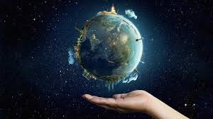

Introduction
What is an Epoch?
Your guess | Actual definition
What is the Anthropocene?
Your guess | Actual definition
Notes from intro video
Notes from reading

Mapping the Anthropocene
Your groups location
Agents of change
Land use changes
Possible impacts on the environment
Possible impacts on people
Brief paragraph summary (location, causes and consequences of change)

