Waves – Significant Concepts X-Word Puzzle
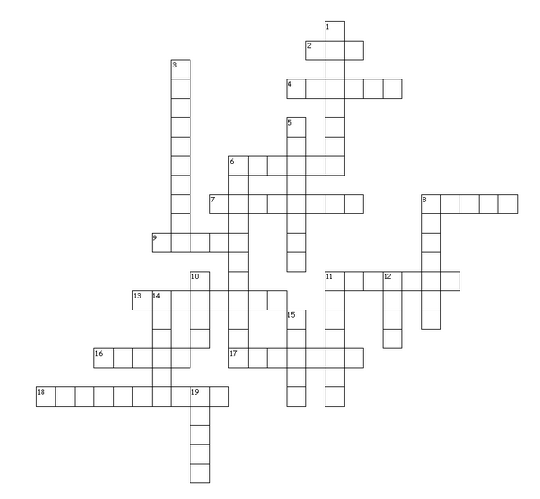

Clues

Across

2. The state when the wind is transferring energy to the sea (the birth stage in a waves life cycle)
4. The lowest part of a wave
6. This is released when waves break
7. Waves start to break because of _________ between the sea floor and the bottom of a wave
8. Lines of energy that travel across water
9. The distance across which the wind blows
11. Another name for a tsunami wave
13. A country that was affected by the 2004 Asian tsunami
16. The country the name Tsunami came from
17. A country that was affected by the 2004 Asian tsunami
18. Over 150 000 people died in this country as a result of storm surge caused by a typhoon in 1991

Down

1. This is one of the factors that influence the size that a wave can grow to
3. An abnormal rise in sea water level generated by a storm
5. The longer the __________ of the wind the larger the wave
6. These generate tsunamis
8. You can help to reduce the impacts of a tsunami by installing a ____________ system
10. Transfers energy to the water through friction
11. A sport invented in Hawaii to ride waves
12. The name of the zone where waves break (the death stage in a waves life cycle)
14. A tsunami is a form of natural ________
15. A knowledge of wave processes is useful because so many human activities are located on or near the ____________
19. Waves that are independent from the wind (the maturity stage in a waves life cycle)

