Urban Land Use Analysis Activity

Syllabus Point: Factors affecting the pattern of urban economic activities (retail, commercial, industrial), including physical factors, land values, proximity to a central business district (CBD) and planning

Task: look at each of the land use maps of the cities and take notes on the patterns within the city.

Brussels, Belgium
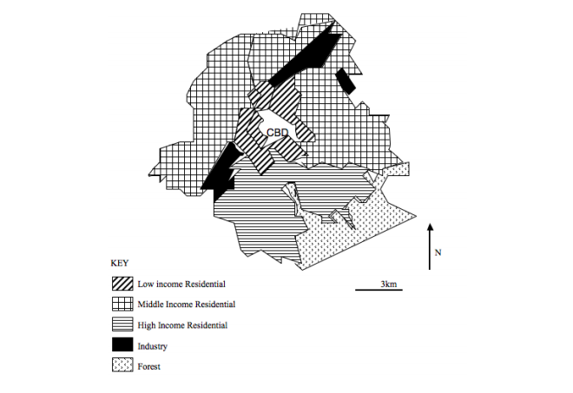

Commercial | Industrial | Residential
Other features
Land Use Model

Ipswich, England
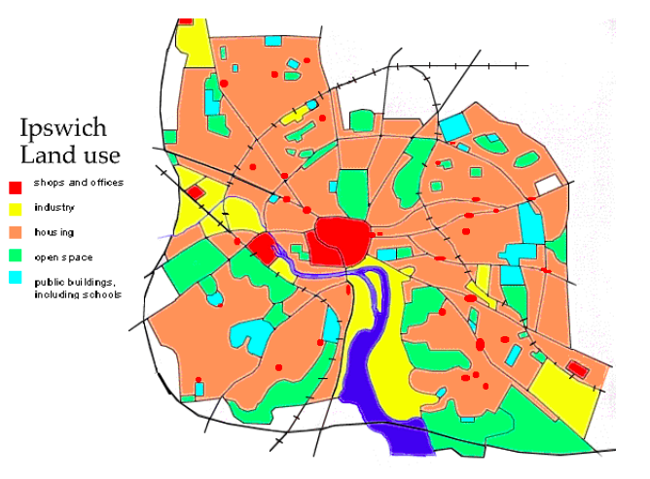
Commercial | Industrial | Residential
Other features
Land Use Model

Pune, India
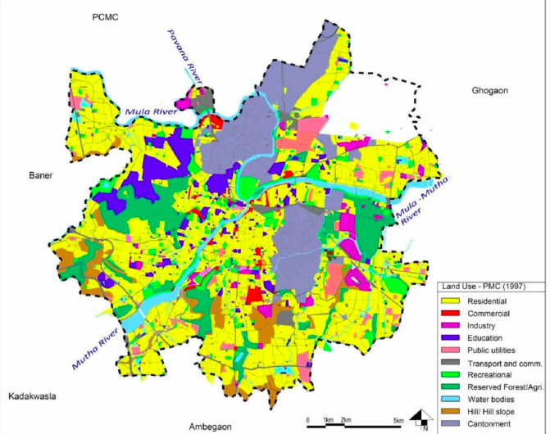

Commercial | Industrial | Residential
Other features
Land Use Model

Manila, Philippines
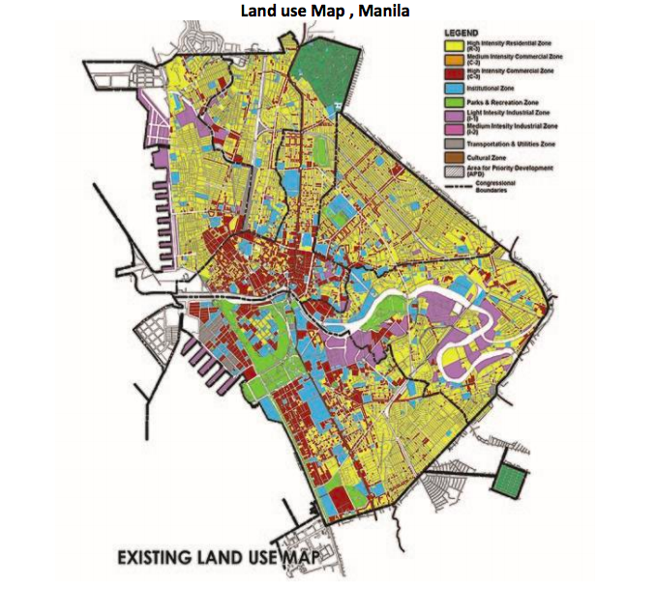
Commercial | Industrial | Residential
Other features
Land Use Model

