Urban Homogenization Processes Reading
Urban environment have been under a process of homogenization for a long time. Cities’ richness of stimuli is many times reduced to its minimum, with the aim of creating a comfortable environment, where things, events and people are predictable. In order to explain this more clearly, I have differentiated three different categories or realms for urban homogenization affecting the form and function of the city.
Sensorial homogenization
The urban space arises from the need of a domesticated built space; an urban space that helps to improve the efficiency of movement and circulations through the space, as well as the relations between the different functions. It is ultimately an environment made for efficiency. However, if efficiency is the only purpose on the design of the built environment, we are losing the sensorial richness of the city that would increase our experiences of the space. The tendency to regulate the shape, materiality, sound, and even odour of our environment leads to a similar and predictable urban space.
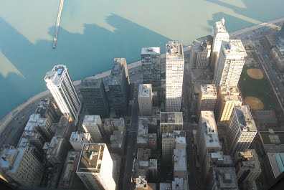

Functional homogenization
The 19th century city used to mix all uses in it, such as housing, working, and leisure. On the contrary, today’s cities tend to fragment their space into their different functions. Thus, in a city we can find residential areas, business districts, or shopping malls, clearly delimitated spatially and functionally. This has been possible thanks to the technological advance in communications and transportation developed during the 20th and 21th centuries. On the one hand, it is true that this separation of functions helps to improve the functioning of cities. On the other, it generates homogenous clusters that only work in specific periods of time and for specific people, impoverishing the urban experience.
Social homogenization
Gated communities or ghettos are the extreme examples of the social homogenization of cities. Places where not only the difference is not wanted, but even banned. But most cities suffer this process in less evident ways, such as gentrification or urban sprawl. The fear to the strange and unknown leads sometimes to alienation and isolation of similar citizens into ‘save’ and known spaces. However this action alienates them also from learning and discovering new things from others. All the intensity and learning richness that the city offers by putting together different people is lost in this kind of strategies. As Daniel Innerarity states, “the fear to ‘others’ grows proportionally to the distance of homogenous neighbourhoods from the city” (Innerarity 2006, 117).
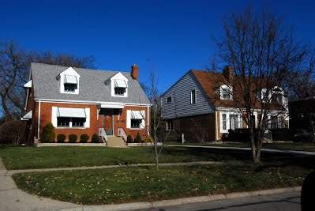
These homogenization processes prevent us from experiencing an urban life that enriches ourselves and allow us to learn from others. In this sense, the public space plays a fundamental role as the realm for our life in common. It is there where we can observe and socialize with others. Streets, plazas, parks, cafes, museums, etc. represent a space free of private control, where we all meet and share. That is why public spaces are the essence of the urban life and should be protected from any homogenization process.

