The UN SDGs – Intro & Forum

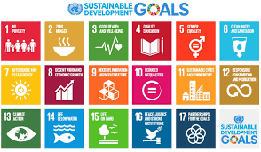

Introduction
What are the UN SDGs?
Take notes on the back ground to the UN SDGs
What do you thing about the UN SDGs? Write a paragraph on this.
Are they are good idea?
Do they target the right things?
Do you feel any connection with them?

SDG Investigation:
Goal Number & Name:
What are the aims of this goal?
Why is this goal important?
Describe 2 current events that are related to your goal.
Explain how meeting the goal could reduce the impact of this current event
How could meeting this goal impact student at NIST?
What types of actions could students at NIST take to help meeting this goal? You should refer to the 4 types of service for this (on adorngeo)
Direct:

Indirect:

Advocacy:

Research:

Summary pitch: Make a final pitch on why your goal is important and why NIST students should engage in action to help meet the goal.

