Types of Tourism

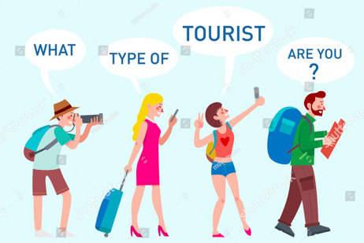

Type: Business tourism
Definition: Travel for the purposes of work.
Characteristics: Often city-based, with workers staying in high quality hotels near their offices. Chain hotels are common (such as Mariott or Hyatt).

Type: MICE tourism
Definition: Meetings, incentives, conferences and exhibitions tourism.
Characteristics: Very similar to business tourism, but with larger numbers of business people coming together for events.

Type: Leisure tourism
Definition: Travel for the purposes of enjoyment.
Characteristics: There are many types of leisure tourism, which can be split into mass tourism and niche tourism.

Type: Mass tourism
Definition: Tourist activities on a mass scale; many people engage in the same activity in the same location
Characteristics: The traditional relaxing ‘bucket and spade’ beach holiday (Spain, Thailand). Usually short-term e.g. one or two weeks. Families are well catered for. Hotels, restaurants and activities are usually offered in the tourist’s home language.

Type: Niche tourism
Definition: Tourist activities that are popular among a small group of people. Also known as specialised tourism.
Characteristics: Often deliberately aim to provide an experience beyond relaxation, such as engaging with a new culture, participating in voluntary work, or experiencing the natural environment. Other types include visiting historic sites, taking part in physical adventure activities (such as mountain climbing or scuba diving), or receiving medical care.

