Tsunami Worksheet

Instructions: use the resources on adorngeo or https://www.bbc.com/bitesize/guides/zbfrd2p/revision/2
to complete the following:

- Watch the video ‘The science of Tsunamis’. Then annotate this diagram to explain the causes of tsunami.

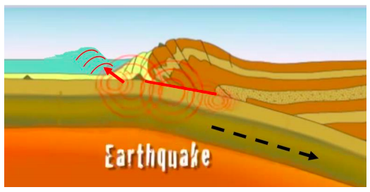

- Look at the diagram below that shows the difference between tsunami waves in deep and shallow water. State what happens to wave height, length and speed for both:

- A tsunami in deep ocean:

- A tsunami approaching shore:

- How could knowledge of this help people to escape an oncoming Tsunami? Hint, watch the video ‘Lessons save lives’ on adorngeo.

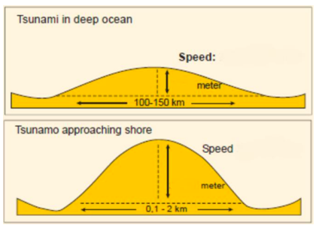

- Look at the diagram ‘How a Tsunami Forms’. Write one paragraph to sum up this process.

- Watch the BBC video on the Asian Tsunami of 2004: make a list of:

- Causes:

- Consequences:

