Trends in Biotic Resource Use Notes

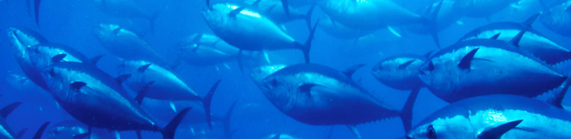

Syllabus Link: Trends in biotic resource use (fish and mammals) and the viability of alternatives to overfishing, including aquaculture, conservation areas and quotas

Task: Use the handout reading from Planet Geography and the resources on adorngeo and in google classroom to take notes on this topic.

- Define the terms
  - Bycatch
  - Sustainable yield
  - Maximum yield
  - Reproductive age
  - Quota
  - Deep sea trawling
  - Marine reserve

- Describe the global pattern of fishing and identify the top 5 nations that catch the most ocean fish.
- Describe the global trend in the state of marine fish stocks over the last few decades.
- Explain why marine fishing has increased.
- Explain how the tragedy of the commons can apply to overfishing of the oceans.
- Identify longer-term consequences for the environment and economy of overfishing and explain what fishing techniques make this worse.
- Summarize one case study of overfishing of either tune or cod.
- Discuss alternatives to overfishing.
- Explain how marine reserves work and give specific details of one.
- Define aquaculture and evaluate it’s effectiveness as an alternative to deep sea fishing.

