The ‘Tragedy of the Commons’
How do we manage resources that seem to belong to everyone? Natural food reserves, energy resources like fossil fuels, a clean environment, with clean air, water and soil belong to everyone and yet are protected by no-one. Today, protecting such common resources has become a challenge, not only on the local scale but on national and global ones as well.
In the 1960s, ecologist Garrett Hardin invoked the analogy of a "commons" in support of his idea that as human populations increased, there would be increasing pressure on finite resources at both the local and particularly the global levels, with the inevitable result of overexploitation and ruin. He called this the "tragedy of the commons."
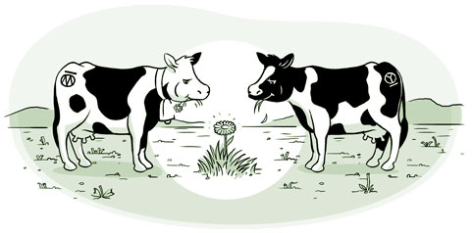
The tragedy of the commons develops in this way. Imagine a piece of land open to everybody. It is expected that each herdsman will try to keep as many cattle as possible on the commons. Such an arrangement may have worked reasonably well in the past because tribal wars, poaching, and disease kept the numbers of both man and beast well below the carrying capacity of the land. Eventually, however, comes the day of reckoning.
As a rational being, each herdsman seeks to maximize his gain. More or less consciously, he asks, "What is the gain to me of adding one more animal to my herd?" This gain has one negative and one positive component.
- The positive component is a function of the addition of one animal. Since the herdsman receives all the proceeds from the sale of the additional animal, the positive gain is nearly + 1.
- The negative component is a function of the additional overgrazing created by one more animal. Since, however, the effects of overgrazing are shared by all the herdsmen, the negative effect for any particular decision-making herdsman is only a fraction of - 1.
Adding these together, the rational herdsman concludes that the only sensible course for him to pursue is to add another animal to his herd. And another. But this is the conclusion reached by every rational herdsman sharing a commons. Therein lies the tragedy. Each man is locked into a system that compels him to increase his herd without limit - in a world that is limited. Freedom in a commons eventually brings ruin to all.
In a reverse way, the tragedy of the commons reappears in problems of pollution. Here it is not a question of taking something out of the commons, but of putting something in - sewage, or chemical, radioactive, and heat wastes into water; toxic, even dangerous fumes into the air. The calculations are much the same as before. The rational individual finds that his/her share of the cost of the wastes he/she discharges into the commons is less than the cost of purifying wastes before releasing them. Since this is true for everyone, we are locked into a system of "fouling our own nest," so long as we behave only as independent, rational, free enterprisers.
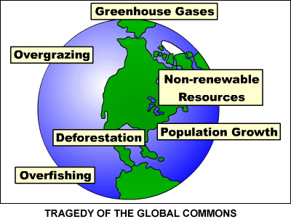
The tragedy of the commons may partially be prevented by private property, or something like it. But the air and waters surrounding us cannot fenced off, and so the tragedy of the commons globally must be prevented by different means, by laws or taxes that make it cheaper for the polluter to treat his/her pollutants than to discharge them untreated. Unfortunately, the owner of a factory on the bank of a stream - whose property extends to the middle of the stream - often has difficulty seeing why it is not his/her natural right to muddy the waters flowing past his/her door. Laws therefore need to change to protect the commons.
Adapted from: http://www.sustainable-environment.org.uk/Earth/Commons.php

