Tourism Hotspots

What is a tourism hotspot?
Tourism hotspots are places that experience high levels of tourist arrivals. These places can also be called tourist honeypots. The term honeypot usually refers to a small area such as a village in a national park, while hotspots operate at a variety of scales from small villages to entire regions.

Hotspots exist in places such as:
- Areas of outstanding natural beauty
- Historic city centres
- Coastal areas with sandy beaches in hot countries

In addition, these places must be:
- Easy to access
- Secure (not susceptible to terrorist attack, for example)
- Safe (free from disease; not experiencing frequent natural hazards)

Tourism hotspots usually have a very large number of visits at the same time. This can lead to seasonal hotspots and diurnal hotspots.

Seasonal hotspots have high levels of tourism at specific times of year, such as the summer months when Spanish beaches become very busy. On the graph below, the level of tourism is very low outside the warm summer months but reaches a rapid peak as tourists arrive for summer holidays from other countries.

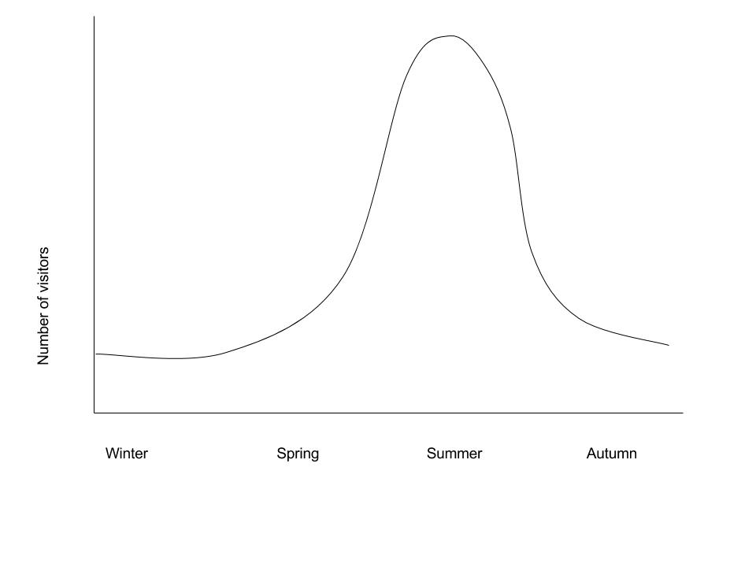
- Theoretical seasonal variation in visitors for a Spanish beach resort

Diurnal hotspots have high levels of visitors at certain times of day, such as day trippers who visit Venice. The city receives many tourists during the middle of the day and far fewer in the morning or late afternoon as people return to their cruise ships for the evening. The number of tourists peaks in the middle of the day as tourists arrive and gradually leave after lunch.

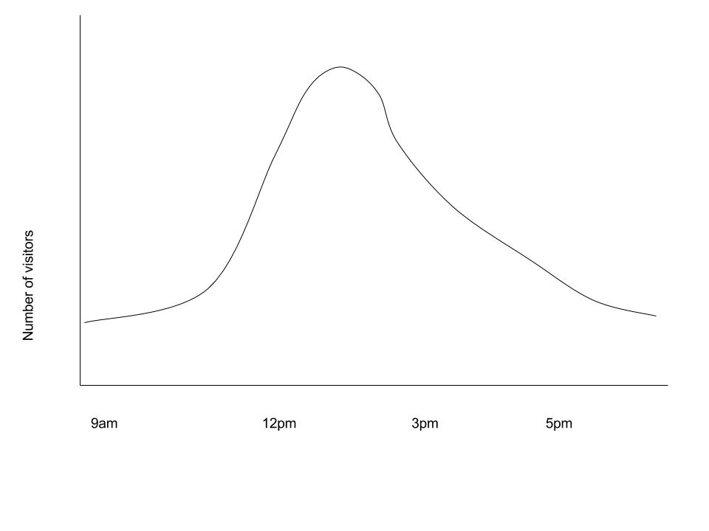
- Theoretical diurnal variation in visitors for a historic Mediterranean town centre

Reasons for hotspot growth

There are many factors that can encourage the growth of tourism in a specific area. These are in addition to the factors that increase tourism in general, such as increasing income, leisure time and infrastructure.

Human factors | Physical factors
Buildings  Festivals  Cultural attractions such as museums  Availability of accommodation  Ease of transport  Fame (e.g. through advertising, movies)  Trending (social media attention) | Mountains  Rivers  Coastlines  Volcanoes  Climate  Wildlife

These growth factors are effectively different types of tourist resources. These can be split into primary and secondary tourist resources. Primary tourist resources were created for non-tourist reasons but are today used by tourists. Secondary tourist resources were created specifically for tourists as one of their main functions.

Aside from the tourist resources in the destination itself, there are several other reasons why tourism hotspots grow.

Government policy: Government policy can encourage the development of a tourist hotspot. Deliberately attracting tourists to one location can help keep other locations tourist free. This is very closely connected to the issue of ‘zoning’.

Zoning: Local government plans often involve the ‘zoning’ of an area. This means that some areas are put aside for conservation, others for tourism, others for local use, and so on. Each zone has specific activities within it. Tourist hotspots may develop in areas such as parts of a city centre, village centres or specific mountains that are deliberately chosen to develop the infrastructure required for large numbers of visitors.

Gateway / entry points: Several tourism hotpots are not actually destinations in themselves, but places where people have to pass through in order to get to the place they are aiming for. Due to the number of people passing through, these places often develop secondary tourist attractions in themselves, and become tourist centres. Bangkok is a travel hub for those entering or stopping over in Thailand so gains a large number of visitors. Lukla in Nepal, which is the main town at the beginning of the trail to Everest Base Camp. Another example are towns on international borders where people can cross from one country to another, such as Calais in France which has a high number of visitors because it is the nearest continental port to the United Kingdom.

Advertising: Advertising and travel programmes often promote the same locations to the extent they become very popular. For example, the Grand Canyon is known across the world as a primary tourist attraction, resulting in around five million tourist visitors each year (GrandCanyon.Com, 2017).

Word-of-mouth and social media: Some places are less well known but still attract a large number of visitors as word of mouth travels. Social media, including sites like Instagram and Facebook, can ensure that travel trends spread quickly. This can sometimes result in the rapid development of a tourist hotspot to the extent that the local services cannot effectively cope. The Philippine island of Boracay was inundated by 1.56 million visitors in 2015, over the government’s target limit of 1.5 million (Burgos, 2016). The excessive tourism caused traffic jams, air and water pollution and lead many visitors to question the over-development of the island and its role in destroying the beach paradise promised on many social media posts.

Source: Adapted from https://geographycasestudysite.wordpress.com/tourism-hotspots/

