The Eight Great Powers of 2017

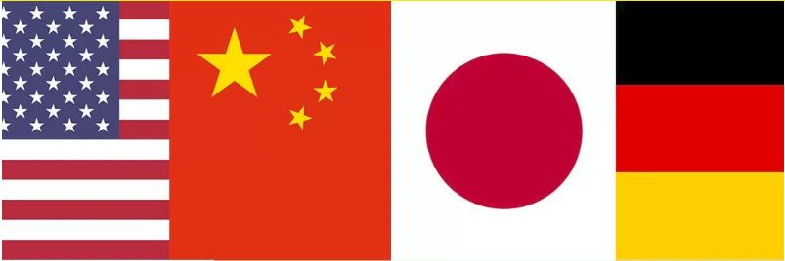

1. The United States of America
No surprise here: as it has for the last century, the United States remains the most powerful country on earth. America’s dynamic economy, its constitutional stability (even as we watch the Age of Trump unfold), its deep bench of strong allies and partners (including 5 of the 7 top powers listed below), and its overwhelming military superiority all ensure that the United States sits secure in its status on top of the greasy pole of international power politics.
Not that American power increased over the past year. 2016 may have been the worst year yet for the Obama Administration, bringing a string of foreign policy failures that further undermined American credibility across the world. In Syria, Russia brutally assisted Assad in consolidating control over Aleppo and sidelined Washington in the subsequent peace talks. China continued to defy the American-led international order, building up its military presence in the South China Sea and reaching out to American allies like the Philippines. Iran and its proxies continued their steady rise in the Middle East, while the Sunnis and Israel increasingly questioned Washington’s usefulness as an ally. Meanwhile, the widespread foreign perception that Donald Trump was unqualified to serve as the President of the United States contributed to a growing chorus of doubt as to whether the American people posses the wit and the wisdom to retain their international position. Those concerns seemed to be growing in the early weeks of 2017.
In the domestic realm, too, America’s leaders did little to address the country’s pressing long-term economic problems, nor did they inspire much confidence in the potential for effective bipartisan cooperation. The populist surge that almost gave the Democratic nomination to the Socialist senator Bernie Sanders and brought Donald J. Trump to the White House was a sign of just how alienated from politics as usual many Americans have become. Foreigners will be watching the United States closely in 2017 to see whether and how badly our internal divisions are affecting the country’s will and ability to pursue a broad international agenda.
Still, for all this gloom, there was good news to be had. Fracking was the gift that kept on giving, as the United States surpassed Saudi Arabia and Russia to become the country with the world’s largest recoverable oil assets and American businesses discovered new innovations to boost their output. The economy continued its steady growth and unemployment fell to a pre-financial crisis low, with the Fed’s year-end interest rate hike serving as a vote of confidence in the economy’s resilience.
As the Trump administration gets under way, the United States is poised for what could be the most consequential shift in American policy in several generations. But regardless of what change the coming year brings, it is important to remember that America’s strength does not derive solely or primarily from the whims of its leaders. America’s constitutional system, its business-friendly economy, and the innovation of its people are more lasting sources of power, proving Trump critics right on at least one count: America has never stopped being great.

2. China (tie with Japan)
In 2016, China cemented its status as the world’s second greatest power and the greatest long-term challenger to the United States. In the face of American passivity, Beijing projected power in the South and East China Seas, built up its artificial outposts and snatched a U.S. military drone at year’s end. Aside from its own forceful actions, China also enjoyed several strokes of good fortune in 2016, from the election of a China-friendly populist in the Philippines to the demise of the Trans-Pacific Partnership, which will grant China a new opportunity to set the trade agenda in the Asia-Pacific.
China continued to alternate between intimidating and courting its neighbors, scoring some high-profile victories in the process. Most prominent was the turnaround from Manila, as the new Philippine president Rodrigo Duterte embraced China: in part because of his anti-Americanism, but also thanks to Chinese support for his anti-drug campaign and the promise of lucrative trade ties and a bilateral understanding on the South China Sea. Beijing also cannily exploited the Malaysian Prime Minister’s disillusionment with the United States to pull him closer into Beijing’s orbit, while pursuing cozier ties with Thailand and Cambodia.
Not all the news was good for Beijing last year. For every story pointing to Beijing’s growing clout on the world stage, there was another pointing to its inner weakness and economic instability. Over the course of the year, Chinese leaders found themselves coping with asset bubbles, massive capital flight, politically driven investment boondoggles, pension shortfalls, brain drain, and a turbulent bond market. These signs do not suggest confidence in the soundness of China’s economic model.
And despite the gains made from flexing its military muscle, there have been real costs to China’s aggressive posture. In 2016, Vietnam militarized its own outposts in the South China Sea as it watched China do the same. Indonesia began to pick sides against China, staging a large-scale exercise in China-claimed waters. Japan and South Korea agreed to cooperate on intelligence sharing—largely in response to the threat from North Korea, but also, implicitly, as they both warily watch a rising Beijing. And India bolstered its military presence in the Indian Ocean in response to China’s ongoing “string of pearls” strategy to project power there. For all its power, then, China is also engendering some serious pushback in its neighborhood.
The new year finds China in an improved position but also a precarious one, as its economic model falters and it seeks to break out of its geopolitical straitjacket.

