The Characteristics of Urban Places

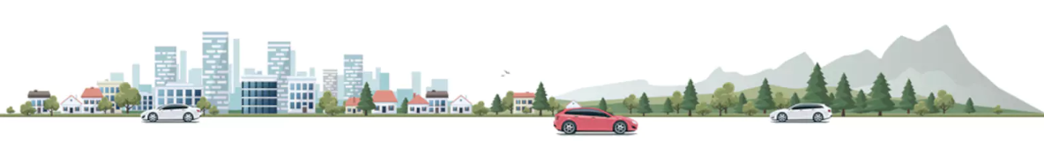
Syllabus Links: The characteristics and distribution of urban places, populations and economic activities

Task: In pairs you need to use google earth, google earth engine, and Wikipedia to find the characteristics of some selected urban settlements.

- Google earth https://www.google.com/earth/
- Google earth engine https://earthengine.google.com/

You need to find out as much as possible about your designated urban area and record the information in the table below. You will also need to verbally share information with other pairs.

Urban Area Name
Population
Site features
Patterns of land use
(include a screenshot)
Growth process
(Use google earth engine, comment on speed of growth and whether it seems planned, changes in population etc)
Function
Position in urban hierarchy
Brief history

Key Term Definitions

Term | Definition
Urban
Site
Situation
Function
Land use
Urban hierarchy
Planned development
Spontaneous development
Capital city
Primate city
Megacity
Conurbation

