Thailand – Climate Change Vulnerability
Introduction: Thailand, as part of the Mekong River Basin, is struggling to deal with climate change impacts, which result in part from ecological pressures introduced by large hydropower dams, deforestation, coastal erosion and urbanization. Thailand has a rapidly expanding economy which has led to a significant demand for energy. The main natural resources in Thailand are the fishery resources, offshore oil supplies, fertile agriculture land in the central and eastern regions and the large areas of land covered in forests.
Currently, Thailand is home to a population of about 70 million and is particularly vulnerable to extreme weather events, such as floods and droughts, which are becoming more frequent and severe as a result of climate change. For example, in 2011 Thailand experienced its worst ever flood event on record, at a cost US$46 billion for repair and rehabilitation nationally; and US$8 billion in Bangkok alone. The impacts of the flood affected more than 13 million people and resulted in over 680 deaths.

Vulnerability: Thailand has seen a marked increase in temperatures and changes in rainfall patterns over the past thirty years. Both of these changes have a significant effect on food production, particularly rice—the yields of which are essential to national food security. Thailand’s long coastlines, fragile agriculture system and susceptibility to extreme weather events make it vulnerable to the effects of climate change.
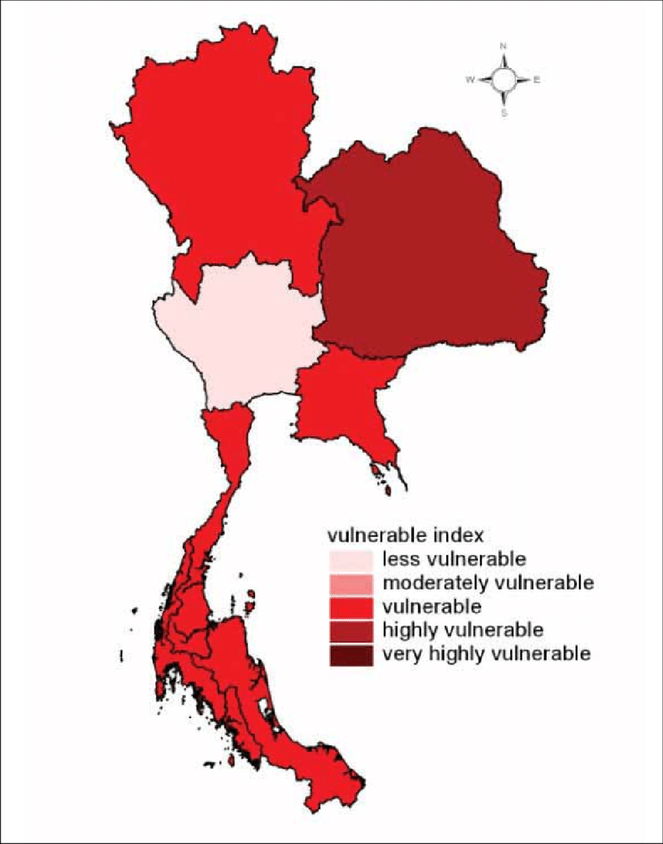

Changes in Climate: More recently, the National Hydroinformatics and Climate Data Center (NHC) recorded a significant period recurrent and prolonged droughts between 2015 and 2016 that led to critically low levels of water in reservoirs nationwide. In 2016, these droughts significantly reduced the length of the growing season, as well as agricultural yields. Furthermore, in an economic study, focusing on trends in extreme weather conditions along the Chao Phraya river basin, it was projected that in the next two decades, extreme droughts could create conditions for dry season irrigated rice production, where total production levels would be reduced by 30.9%.

Sea-level rise: is another impact resulting from climate change, which threatens livelihoods in coastal communities. For example, saltwater intrusion has caused a significant decline in rice yields in the Upper Gulf of Thailand, contributing to the vulnerability of mangrove forests, and degraded coral reefs. These impacts have affected the ecosystem services provided by these natural resources as well as in the fisheries in this region and the livelihoods that depend upon them. Research has shown an increase in the local mean sea level of 5 mm/year over the last 25 years in this region, severe coastal recession may occur in the Upper Gulf in the near future.

Bangkok Threatened: Furthermore, Bangkok, the capital city of Thailand has been identified as a city as particularly vulnerable to climate driven impacts, such as flooding due to both SLR and extreme rainfall events. For example, a case study assuming a scenario of the climate warming by 4°C, without adaptation measures being applied predicts severe flooding in Bangkok. Under these assumptions, 40% of the city would be inundated by extreme rainfall event and a 15 cm SLR by the year 2030. Furthermore, the same event in the 2080’s would inundate 70% of the city with an 88 cm SLR.

Social Impact: Deteriorating environmental conditions have the potential to exacerbate existing social issues such as political unrest, poor economic conditions, food insecurity, inequality, or poverty and cause widespread destruction of livelihoods. According to the long term Global Climate Risk Index produced by the GermanWatch think tank, Thailand had the 10th highest vulnerability and exposure to climate risks for the 20-year period between 1996 and 2015.

Economic Impacts: The potential magnitude of the economic impacts related to climate change may have on at-risk resources, such as rural and urban infrastructure, the productivity of workers, crop production, hydropower dams, or the provision of ecosystem services is a major concern. Conventional studies estimate the net economic cost of climate change for Thailand at US$180 billion/year averaged between 2012 and 2030.Aanalysis can show results that suggest that reduced labor productivity is the most the significant cost associated with climate change in the Lower Mekong Basin. It also suggested that Thailand’s economic risk associated with all climate change impacts, including infrastructure, is equivalent to 14% of total rural GDP.

