Thailand Case Study:

Anti-Human Trafficking Response
2019 US Trafficking in Persons Report Summary:
The Government of Thailand does not fully meet the minimum standards for the elimination of trafficking but is making significant efforts to do so. The government demonstrated overall increasing efforts compared to the previous reporting period; therefore Thailand remained on Tier 2. These efforts included identifying more victims, sentencing convicted traffickers and complicit officials to significant prison terms, developing several manuals in partnership with civil society to standardize anti-trafficking trainings and policies.

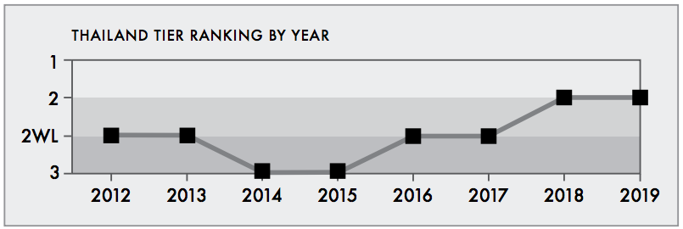

However, the government did not meet the minimum standards in several key areas. The government prosecuted and convicted fewer traffickers and investigated only 43 cases of labor trafficking. The government restricted the movement and communication of victims residing in government shelters, official complicity continued to impede anti-trafficking efforts, and officials did not consistently identify cases of trafficking, especially labor trafficking.

Thailand’s 2016 Trafficking Policy
Thailand’s efforts and key development in combatting human trafficking along the five strategic dimensions or 5 Ps namely: Policy, Prosecution, Protection, Prevention and Partnership. The summary of key achievements is as follows:-
1. Policy: Combatting trafficking in persons remains a national agenda. In 2016, the Royal Thai Government has translated its commitment to “zero tolerance” policy against human trafficking into action through several measures and implementations. The Government substantially increased the overall anti-human trafficking budget, up to 23.88 percent compared to FY2015, to provide sufficient resources to support actions in all key areas. The Government also intensified legal reforms.
2. Prosecution: Improved quality and speed of legal proceeding was due to better coordination between the police, prosecutors, the court of justice, and other law-enforcement agencies. The Government also tackled head-on the economic incentives of traffickers by utilizing other regulations, including anti-money laundering and administrative powers, to complement anti-human trafficking efforts. Significant achievements and progress made in 2016 were the increased number of human trafficking cases uncovered, investigated, indicted and convicted.
3. Protection: The Government adopted a victim-centered approach and focusing on protecting vulnerable groups. The government strengthens protection services and improve rehabilitation, care and welfare provision for TIP victims by equipping victims with skills necessary for embarking on new life path and reintegration into their respective communities, as well as developing rehabilitation plan aimed at empowering victims and protecting re-victimization
4. Prevention: Thailand in 2016 strengthened its labor and migrant workers management system to help eliminate legal loopholes in laws and regulations, and reduce vulnerabilities for migrant workers, women and children. This included the introduction and enforcement of new law regulating migrant labor recruitment agencies while reducing the costs and time for migrant workers to enter Thailand.
5. Partnership: To address the transnational nature of human trafficking, the Government has deepened and broadened its partnerships with all stakeholders, including foreign governments – particularly neighboring countries – the private sector, international organizations, and civil society organizations – domestic and abroad, including with neighboring countries and regional cooperation. In addition, the Government also deems the United States a significant partner in countering human trafficking and continued to work closely with various U.S. agencies, particularly in law enforcement, such as Homeland Security Investigation, Federal Bureau of Investigation.

