Superheros - The Script

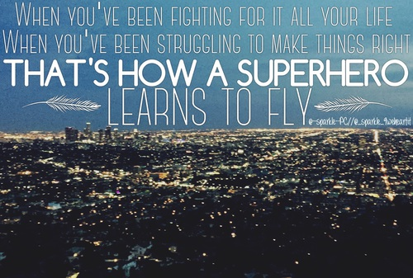

All the life she has seen
All the meaner side of me
They took away the prophet's dream
For a profit on the street

Now she’s stronger than you know
A heart of steel starts to grow

All his life he's been told
He’ll be nothing when he’s old
All the kicks and all the blows
He won't ever let it show

'Cause he's stronger than you know
A heart of steel starts to grow
When you've been fighting for it all your life
You've been struggling to make things right
That’s how a superhero learns to fly
Every day, every hour, turn the pain into power

When you've fighting for it all your life
You've been working every day and night
That’s how a superhero learns to fly
Every day, every hour, turn the pain into power

Oh-oh, oh, oh
Oh-oh, oh, oh
All the hurt, all the lies
All the…

