The Story of Stuff
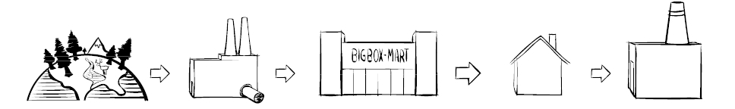
- Identify what is driving the above life cycle of a product? Why does it exist? Answer in a few sentences below.
Extraction | Production | Distribution | Consumption | Disposal

- Make a list of negative factors related to our ”stuff’ based lifestyles. At least three for each one.
Extraction | Production | Distribution | Consumption | Disposal

Term | Definition
Zero waste

Conscious consuming

Closed loop production

Consumer labeling

Corporate social responsibility

Cradle to cradle design

Extended producer responsibility

Government accountability

Local living economies

- Define the following solutions and classify them from the most to the least important

Analyzing and Evaluating “A Story of Stuff”

- What is the overall message of “story of Stuff?”

- What audience do you believe that Annie Leonard is trying to reach?

- What persuasive techniques does Annie use to try to convey her message?

- Why do you think that she uses a 20-minute video format as opposed to another format like an essay, blog or poster?

- Does the author have a bias? Give an example.

- Who might disagree with the video and what would be the basis on which they might disagree?

- Discuss the extent to which you believe that the presenter makes a convincing argument.

- Has the video changed the way in which you think about consumption? How?

