Social Enterprise Exploration

Part One: Individual Interests and talents
What types of social or environmental issues am I interested in? An image of the UN SDGs is included below to help you think about this)
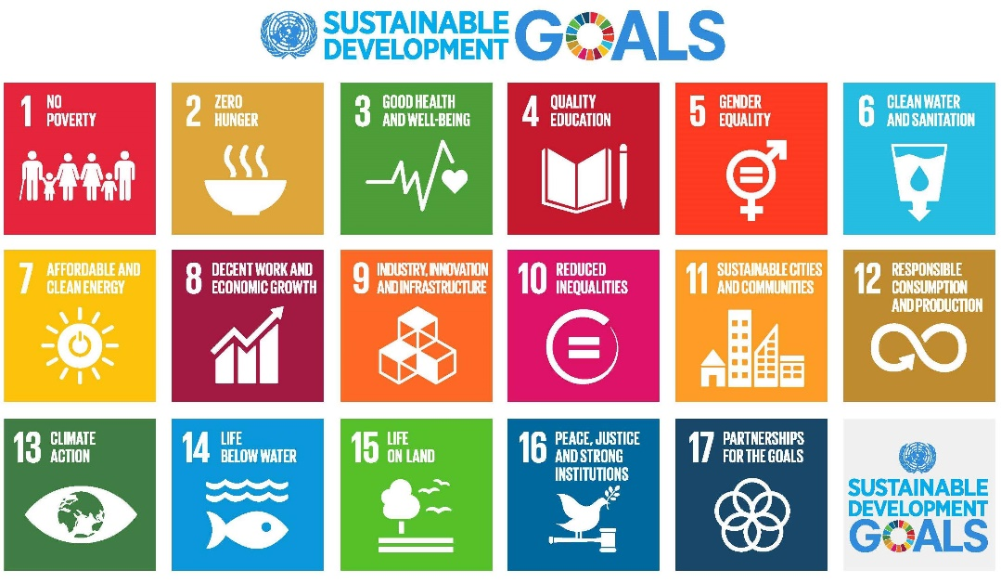
What type of business are you interested in? For example what products or services are interesting to you.
What skills or talents do you have that may be useful for running a social enterprise?

Part Two: Finding partners
Who has similar interests to me in terms of social or environmental issues they would like to address?
Who is interested in a similar type of enterprise?
Who has skills that may be complimentary to a social enterprise?

Part Three: Your why, how & what
Enterprise Name
What is your why? Identify the purpose of your social enterprise
How do you plan to do your why? Identify what is special about your enterprise.
What exactly will you do? Outline your plan to implement your product or service

