Social Enterprise Analysis

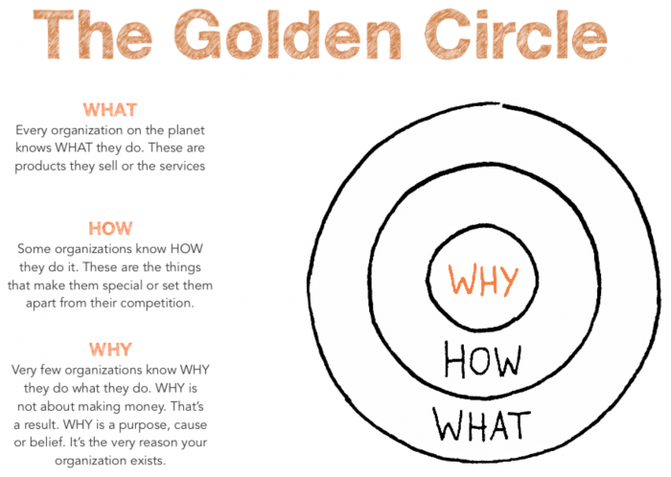

Enterprise Name
Why do they do what they do?
How do they do the why?
What do they do?

