Shanghai –
A Mega City Case Study
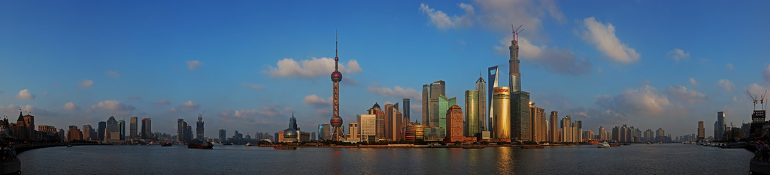

Syllabus Link:

One case study of a contemporary mega-city experiencing rapid growth

Use the handout and resources on the portal or google classroom to do a case study analysis of the growth of Shanghai:
- What? give an overview of the case study (discuss Shanghai as a megacity)and it’s growth

- Where? give a specific relative location of Shanghai and show why this has helped it grow

- When? provide a specific time frame for the growth of Shanghai

- Why? What are the causes for the growth of Shanghai? (think SEEP)

- Who? Who is/was affected? Stakeholders? Who is managing this?

Evaluate the growth

- Social? Positive/negative

- Economic? Positive/negative

- Environmental? Positive/negative

- Political? Positive/negative

Create a quick mind map visual summary of the issue in the space below

