Sand Dunes

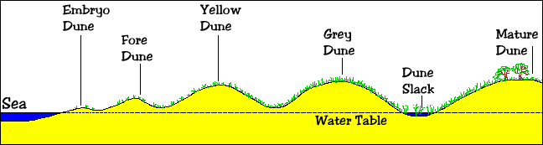
- Sand dunes are accumulations of sand shaped into mounds by the wind. They represent a dynamic landform.
- Beaches are the source of the sand, which, when dried out, is blown inland to form dunes.
- Sand is moved inland by a process known as saltation (the leaping movement of sand or soil particles carried in water or by the wind)

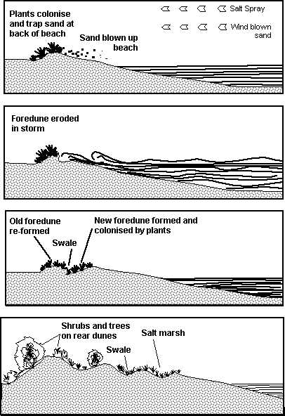
Beach at low tide
Sand accumulates on the beach from longshore drift or onshore currents. At low tide, the sand dries out allowing the prevailing winds to move the loose sand up the beach. Most moves by saltation in a series of short hops but strong winds may be powerful enough to carry the finer sand grains for longer distances. There needs to be a large tidal range which exposes wide expanses of sand at low tide. Much of the fine material is glacial in origin and probably accumulated offshore at the end of the last ice age.

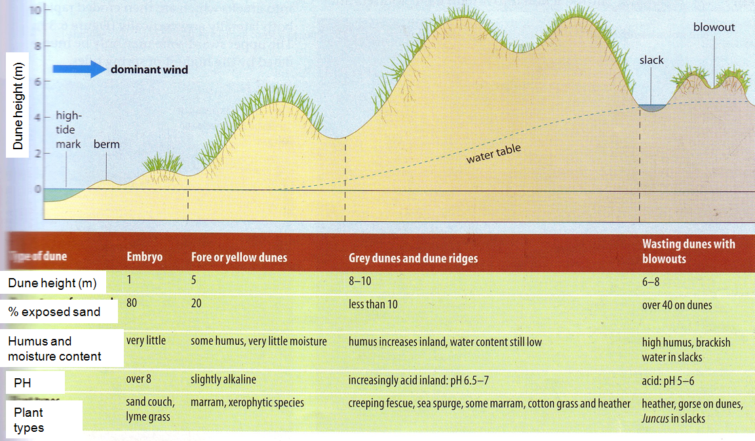

Embryo Dune
Sand is continuously moving around at the top of the beach and it needs an obstruction to break the force of the wind, so that sand begins to accumulate. Seaweed, dead seabirds, driftwood and other detritus may all serve this purpose. These embryo dunes may disappear as quickly as they form but some may eventually be colonised by plants and the sand stabilised. Conditions here are very extreme, with high pH values (over 8), rapid drainage, no humus, high wind speed and lots of salt spray. These young dunes may reach no more than 1 metre in height.

Foredune
The first plants to colonise the foredunes are lyme grass, sea couch grass and marram grass. These plants are drought-resistant and capable of withstanding burial by the shifting sand. As they grow up through the sand, they help trap more sand and so the dunes increase in height. Here the dunes may typically reach up to 5 metres. Other pioneer plants include sea rocket, saltwort and ragwort. The marram grass which may reach 50-120cms. in height, has an extensive root system which helps to bind the sand together and young shoots grow up from the spreading roots or rhizomes. The picture on the right shows a single marram grass plant.

Yellow Dunes
The yellow dunes begin to show a greater diversity of plants as conditions become more favourable. As plants die and decay, a humus layer builds up and this traps both water and nutrients. The pH is now only slightly alkaline (about 7.5), there is more shelter and less salt spray. Marram usually still dominates the vegetation but as can be seen in the picture on the right, other plants are taking hold on the stabilised surface. Plants may include creeping fescue, sand sedge, mosses, lichens, sea holly and sea spurge.The dunes by this stage may well have reached 5-10 metres in height. Up to 80% of the sand surface may now be vegetated. Rabbits and othe mammals may add their droppings to help enrich the developing soil.

Grey Dunes
The grey dunes are much more stable and mosses and lichens fill the few remaining spaces between plants so that vegetation cover may reach 100%. Marram grass becomes less common and appears now in isolated patches. Red fescue, sand sedge, sea spurge begin to dominate. Small shrubs (brambles, gorse, buckthorn) appear for the first time. Environmental conditions 50-100 metres from the sea are much more friendly. There is shelter from the harshest winds, humus is beginning to darken the surface layers and a true soil begins to form. Soil pH is increasingly acid and heathers may take advantage of the acid conditions. Water content is still low and plants have to search for water with their spreading root systems. These large dunes are commonly 10 metres in height and wider than those dunes nearer the shore.

Dune Slacks
The dune slacks are found in between the more mature dunes where the water table reaches the surface causing seasonal or even permanent waterlogging and surface water. Plants which are well adapted to these damp, sheltered hollows include rushes, sedges, cotton grass and creeping willow. If decay is slow, a peaty soil may develop.

Mature Dunes
The most mature dunes are found several hundred metres from the shore. Left undisturbed these dunes develop a soil which can support shrubs and trees including hawthorn, ash and birch. Humans may, as in the picture on the right, plant fast-growing conifers which flourish in the sandy soil. Eventually an oak climax vegetation may develop.

Dune management
The dune system is a fragile one and even small amounts of damage can cause long-term problems. Humans wander onto and through the dunes in increasingly large numbers and small paths which wear through the vegetation cover soon turn into deep gullies as the wind uses the opportunity to carry away the sand. Rabbits in their hundreds dig large holes in the dunes. Eventually, large hollows, called blowouts, are formed and up to 50% of a mature dune may be lost. Plants die and due to loss of habitat, insects, amphibians, birds and animals also disappear.
The dunes may eventually need to be protected by the local authority. This often means fencing off at least part of the dune system so that public access is restricted. This allows damaged dunes to recover and/or ecologically important sections to be protected. Public access to beaches may be via fenced-off pathways. Along the footpaths, information boards can be used to educate the public about why the dune system is important and how they can avoid damaging it. Blowouts can be repaired by trapping the loose sand with barriers - sometimes old christmas trees are used. Although the barriers are unsightly, they are eventually covered up and the vegetation re-establishes itself.

