Rwanda:

Case study of a Gender Equity Policy
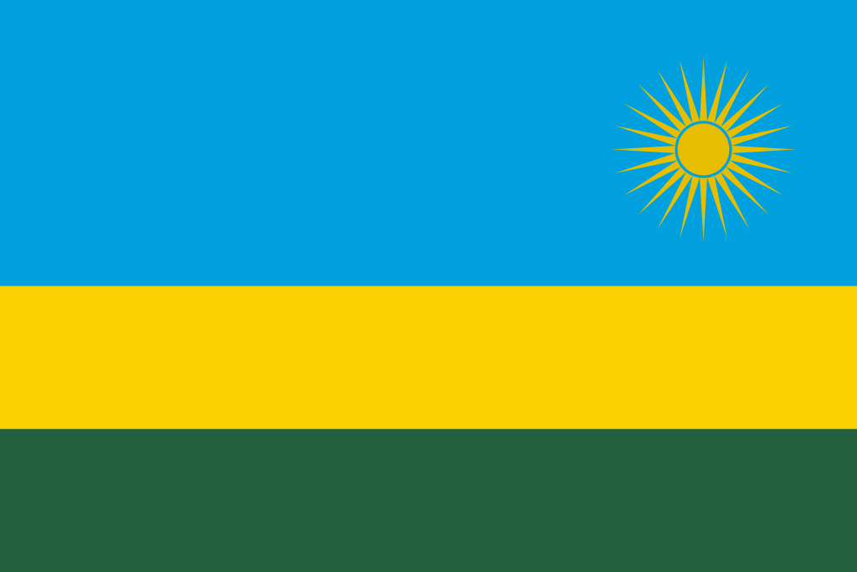

Syllabus Link: Policies associated with managing population change including gender equality policies.

Part 1: Introduction to Rwanda
What do you currently know about Rwanda?
Locate Rwanda on the map below. Then name the countries it borders and state it’s capital.
https://en.wikipedia.org/wiki/Rwanda
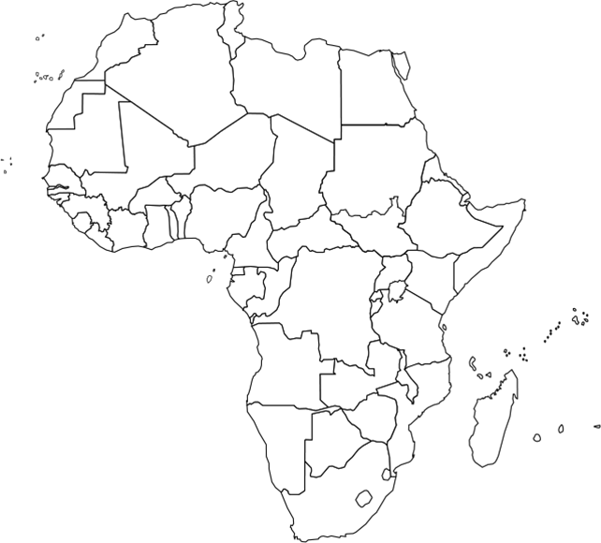
Rwanda’s current population is
It’s population density is
The GDP (PPP) per capita of Rwanda is
It is ranked on the UN HDI

Part 2: Gender Equity Policies in Rwanda
Describe the general trend on this map:
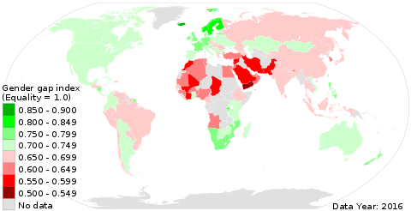

Go to the global gender gap report at https://en.wikipedia.org/wiki/Global_Gender_Gap_Report

In the space below write a statement comparing gender equity in Rwanda to the USA, Iceland, Japan, Thailand, India and Niger.
Use the handout and resources on Adorngeo to do a case study analysis:
- What? give an overview of the case study (situation and policy)

- Where? give a specific relative location

- When? provide a specific time and put the event into context of what was happening around it

- Why? What are the causes for the policy? (think SEEP)

- Who? Who is/was affected? Stakeholders? Who is managing this?

Evaluate the policy

- Social? Positive/negative

- Economic? Positive/negative

- Environmental? Positive/negative

- Political? Positive/negative

Create a quick mind map visual summary of the issue in the space below

