Evaluating a management strategy to achieve
Resource Stewardship
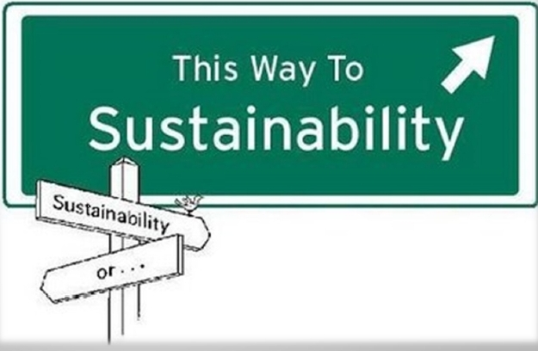

Introduction: In groups of two, research ONE management strategy at a local or national level designed to achieve resource stewardship. Once you have found out the relevant information on your strategy you will need to evaluate it and then create a google presentation.

You will need to take the following steps:
- Select an appropriate case study:
General Stewardship | Circular
Kalimantan, Indonesia (Borneo): Restoring a piece of rainforest  Veta La Palma, Southern Spain: Sustainable Aquaculture  Kamakatsu in Japan  Bhutan: Carbon Nuetral | PUMA IncCycle project  Patagonia  The Plant, Chicago
A list of possibilities is listed above, but you are free to select another management strategy if it is appropriate and there is sufficient information on it.
- Research your strategy. Include an outline what it involves, and consider the positive impacts that the strategy has on resources and the environment.
- Evaluate whether or not you feel the strategy has been successful. Make sure you justify your decision on how effective the strategy has been. Consider:
- What are the initial costs, and maintenance costs?
- To what extent are local communities involved (= a ‘bottom up’ strategy)?
- How many people benefit?
- Government priorities – short-term economic development or sustainability?
- Would this strategy be effective in other places as well?
- Create your presentation.
Include appropriate visuals such as maps, graphs, statistics and images.

Resources:
Sustainable aquaculture:
- https://www.ted.com/talks/dan_barber_how_i_fell_in_love_with_a_fish
- http://content.time.com/time/magazine/article/0,9171,1902751,00.html
- http://www.foodswinesfromspain.com/spanishfoodwine/global/whats-new/features/feature-detail/world-leader-aquaculture.html
Restoring a rainforest:
- https://news.nationalgeographic.com/news/energy/2011/06/110623-tapergie-sugar-palm-biofuel/
- https://www.youtube.com/watch?v=3vfuCPFb8wk
Kamakatsu, Japan
- http://www.businessinsider.com/zero-waste-town-kamikatsu-japan-2017-7
Bhutan: Carbon neutral:
- https://www.youtube.com/watch?v=7Lc_dlVrg5M&t=939s
Patagonia:
- https://www.theguardian.com/business/2017/mar/07/the-north-face-patagonia-saving-world-one-puffer-jacket-at-a-time
Puma InCycle:
- https://www.youtube.com/watch?v=j9zfkYHtuMc
The Plant, Chicago
- https://www.ellenmacarthurfoundation.org/case-studies/synergistic-food-production-space
- http://plantchicago.org/

