Progress Towards Poverty Reduction

Syllabus Link: Global and regional/ continental progress towards poverty reduction, including the growth of the “new global middle class”
Task: Describe global patterns and trends in poverty reduction. Use bullet points for this. Use the resources on Adorngeo for this, there are videos, interactive graphs, an electronic infographic and more.
Trends in Poverty Reduction
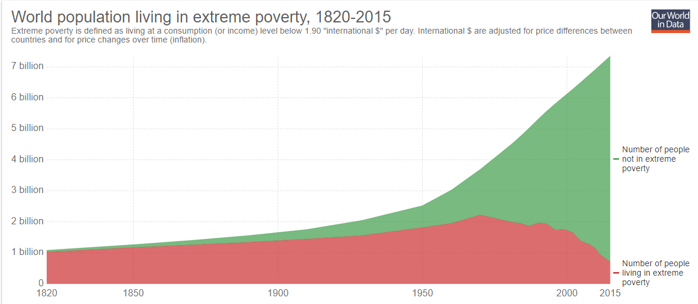
General global trend: Describe the global trend of the world population living in poverty shown in the graph above.
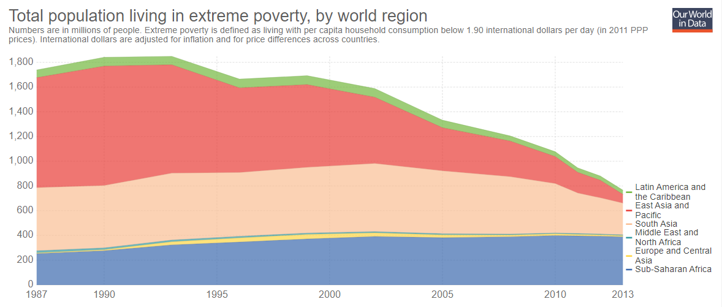

Regional/ Continental Trends: Using the graph above describe regional trends in poverty reduction
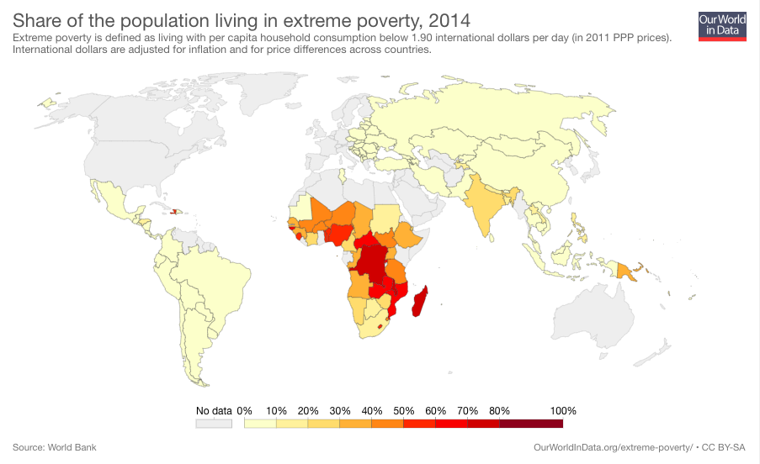
Global Pattern of Poverty: Describe the global pattern of poverty shown in the map above for the years below.
1981:

2000:

2014:

Use this link to make summaries about the reduction in global poverty since 2000.
https://slides.ourworldindata.org/world-poverty/#/title-slide
Syllabus Link: Global and regional/ continental progress towards poverty reduction
Speed Writing:

