Poverty is urbanising and needs different thinking on development
The Guardian October 2012
Urban poor face different hazards to those in rural areas, often having weaker social ties and living cheek by jowl with the rich

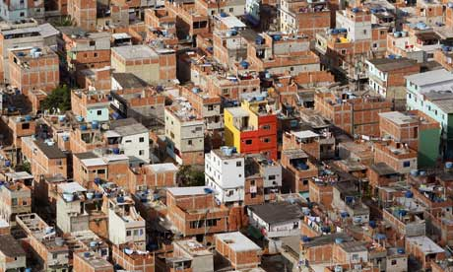
Urban sprawl: the Rio das Pedras favela in Rio de Janeiro, Brazil. Photograph: Vanderlei Almeida/Getty
The share of poverty in the developing world that is located in urban areas has jumped from 17% to 28% in the past 10 years. In eastern Asia, nearly half of all poverty is found in urban locations.

Urban areas capture wide extremes of wealth and poverty, which often exist cheek by jowl. Urban averages hide deprivation on a scale rarely seen in rural areas.

Conflict and security in urban areas are also different, with violent civic conflict– gangs, organised crime, terror and riots – much more of a problem.

Access to services may appear enhanced in urban areas, but often their quality is uneven and the competition for them is intense. As David Satterthwaite has put it: "Having access to a pit latrine is not the same in a rural setting where it is used by one family and can be sited to avoid contaminating water sources, and urban settings where 50 households share it and where there is so much faecal matter that it is very difficult to protect water sources from contamination."

Poor urban dwellers have to deal with high levels of pollutants, toxicity and traffic-related injuries. And diet-related, non-communicable diseases tend to be a bigger problem in urban areas because of the availability of street foods.
Urban hazards are likely to hit harder because of population densities, so disaster-proofing urban planning and infrastructure is vital in promoting urban resilience.
The urban poor tend to buy a bigger share of their food than rural dwellers, hence their hunger and malnutrition is more dependent on growing and volatile food price levels.
The sooner we begin analysing and understanding the diversity of urban contexts, the sooner we will understand how to reduce this growing and relatively neglected share of poverty in a sustainable way.
Edited from: http://www.guardian.co.uk/global-development/poverty-matters/2012/oct/05/poverty-urbanising-different-thinking-development

