Population vs Resources Theory Lifeboat Activity
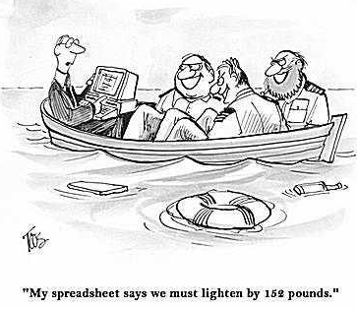
Scenario: There has been a major international conference on the concept of Ecological Footprints and the impact of humans on the Earth’s resource base. On the way back from the conference the boat carrying some of the participants hits an object and begins to sink in a remote part of the ocean. Seven of the conference participants are forced into a lifeboat, but unfortunately there is only adequate space and supplies for five of them. In order for anyone to survive two people will have to leave the lifeboat. In the language of the theorists, the population of the boat has exceeded its carrying capacity and you need to make a population check to ensure at least five people survive. The seven people on the lifeboat are:
- Thomas Malthus
- Esther Boserup
- Julian Simon
- Paul Erlich
- Aurelio Peccei (founder of the Club of Rome)
- David Attenborough
- Dambisa Moyo
Task: You will have to represent one of major players on the lifeboat. You will have to talk to the others on the lifeboat and convince them that you deserve to remain in the lifeboat. You need to inform them about:
- Who you are
- What your theory or theories are on the issue of population vs. resources
- Some current examples of your theory in application in the world
- Why your theory is relevant and useful to the world today
You will present your ideas to the rest of the group (create a google slide presentation). After the presentations there will be a vote to decide who stays on the lifeboat and survives, and who is thrown overboard to drown. The table below will help to organize your thoughts, so make sure you take notes on what each person says.

Notes on the Main Theorists
Theorist | Theories | Current Example | Current Relevance
Thomas Malthus

Esther Boserup

Julian Simon

Paul Erlich

Aurelio Peccei

David Attenborough

Dambisa Moyo

Live or Die Justification
 | Live or Die | Justification
Thomas Malthus

Esther Boserup

Julian Simon

Paul Erlich

Aurelio Peccei

David Attenborough

Dambisa Moyo

Essay Plan
Use information gathered from the lifeboat activity to make an essay plan to address the following exam question.
Discuss the two opposing views (neo-Malthusian and anti-Malthusian) of the relationship between population size and resource consumption.

