Patterns of Economic Activity

1. The Location of Retailing

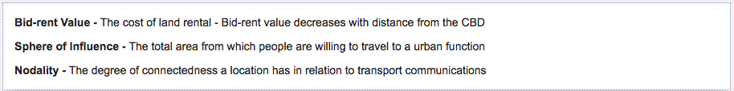
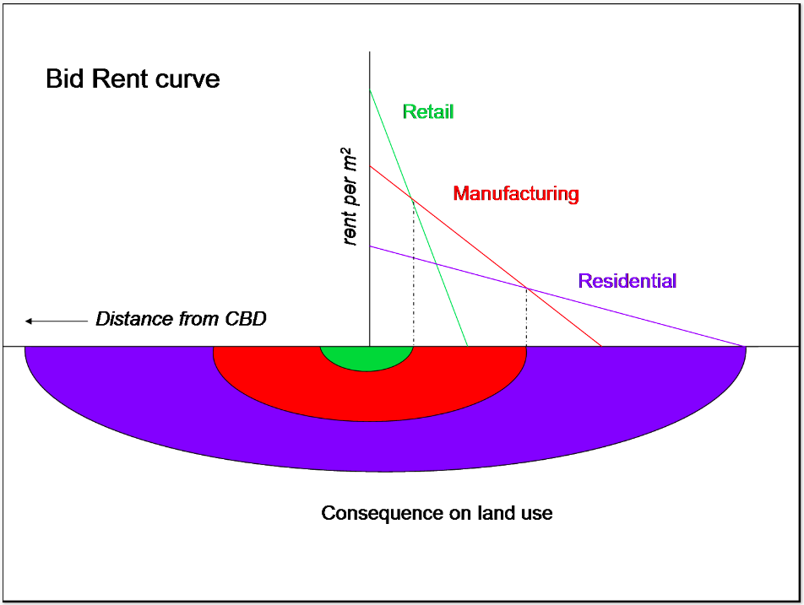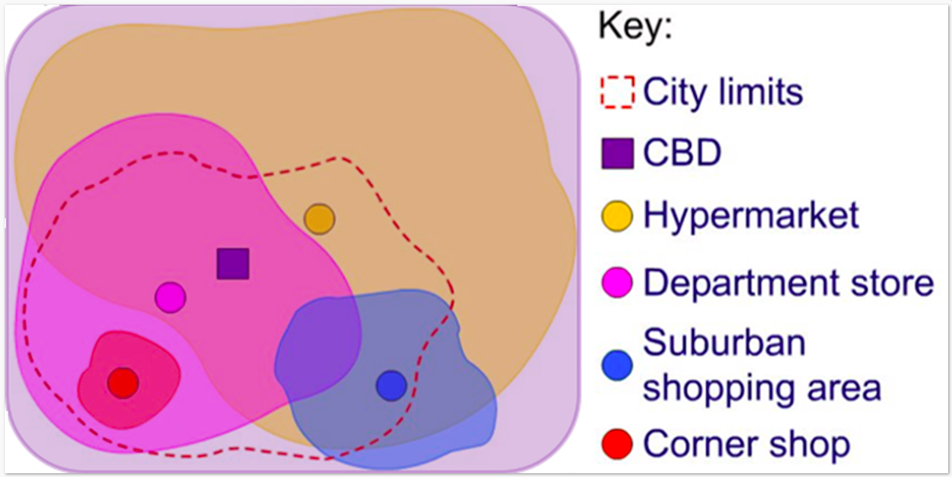

Look at the models then answer the questions below.

- Describe the pattern of economic activity in relation to bid-rent value

- Explain the pattern of sphere of influence for different urban functions.

- Why is the sphere of influence for the CBD larger than all the individual functions?

- What factors influence the site of an urban area's sphere of influence?

2. Out of Town Retailing

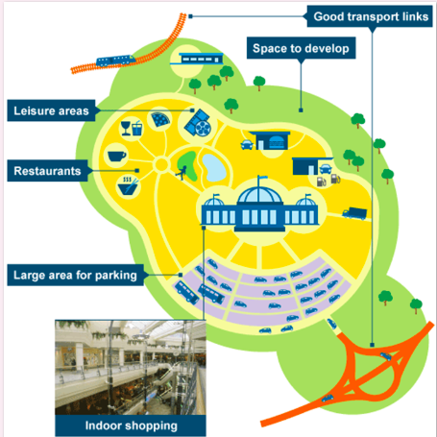

Study the diagram above and identify:
- The reasons why economic activity like out-of-town shopping locates in the RUF
- The advantages of out-of-town shopping for consumers
- What other types of economic activity locate in the RUF for the similar reasons?

