Patterns and Trends in Availability and Consumption of Food
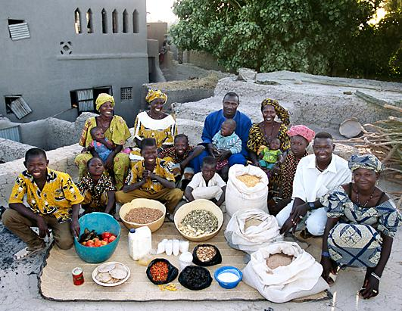
Syllabus Link:
An overview of global patterns and trends in the availability and consumption of food, including changing diets in middle-income countries
Key terms
Nutrition transition: A change in diet from staple carbohydrates towards meat and fish proteins and dairy products. This happens typically when incomes rise from US$2 a day to US$10 a day.
Global patterns
In food availability:

In food consumption:

Global trends
In food availability

In food consumption:

Go to the What the World Eats visualization https://www.nationalgeographic.com/what-the-world-eats/ and comment on trends in consumption for:
- The global trend
- 2 LICs
- 2 MICs
- 2 HICs

Interesting facts
Additional Notes

