Oceans System Introduction Summary

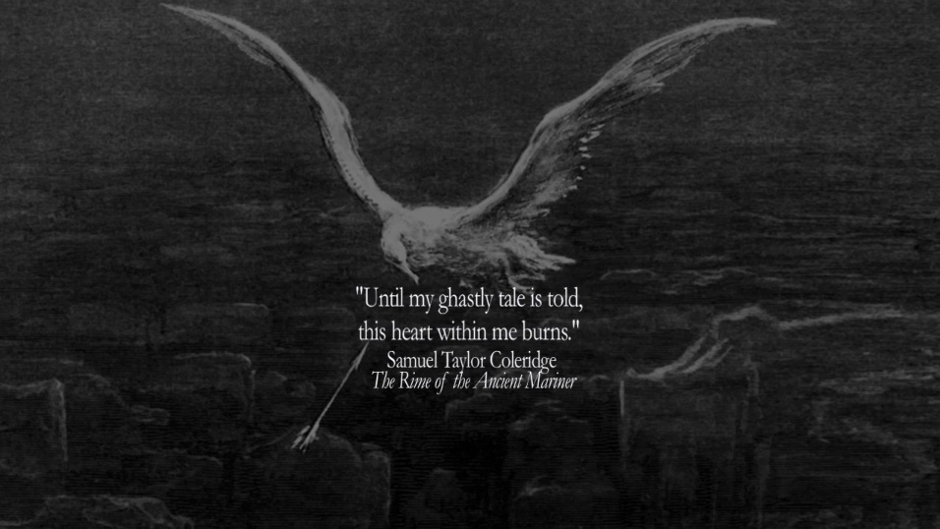
Answer the following questions about your system.

- Is your system a natural system or a human generated system?

- What are the different component parts?

- What are the main inputs and outputs of your system? Create a simple systems diagram to show this. You can adapt the one below.

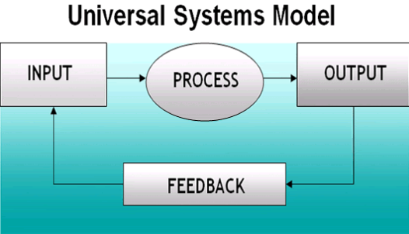

- Explain how the system functions (put into words your diagram above!)

- Is your system dynamic or static? Explain your reasons for this.

- What other system(s) is it dependent upon? Create a systems diagram to show interactions with other systems.

- The statement of inquiry for this unit is:

‘A balance between human and ocean systems is essential for a sustainable future’

Examine how the statement above helps explain who killed Albert Ross..

