Ocean Pollution Management Notes

Syllabus Link
Strengths and weaknesses of initiatives to manage ocean pollution, including local and global strategies for radioactive materials, oil and plastic waste

Task: You need to use the handout and video/ reading resources on adorngeo http://www.adorngeo.com/4-ocean-management-futures.html and your text book from pages 99-102 to take notes on the impacts of and management possibilities of three significant types of ocean pollution.

Global Extent
Using the map below describe the global distribution of human impacts on marine ecosystems
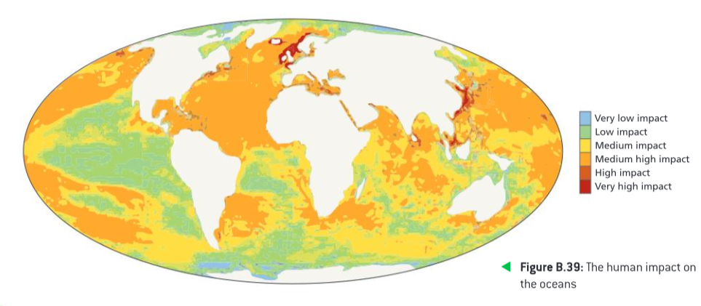

Radioactive material
Identify why it is a problem & give some examples. | State a local initiative and evaluate it’s effectiveness to manage ocean pollution | State a global initiative and evaluate it’s effectiveness to manage ocean pollution

Oil
Identify why it is a problem & give some examples. | State a local initiative and evaluate it’s effectiveness to manage ocean pollution | State a global initiative and evaluate it’s effectiveness to manage ocean pollution

Plastic Waste
Identify why it is a problem & give some examples. | State a local initiative and evaluate it’s effectiveness to manage ocean pollution | State a global initiative and evaluate it’s effectiveness to manage ocean pollution

