Nexus: Security and Inter-connectivity
Syllabus Link: The water–food–energy “nexus” and how its complex interactions affect:
- national water security, including access to safe water
- national food security, including food availability
- national energy security, including energy pathways and geopolitical issues
Nexus Definition:
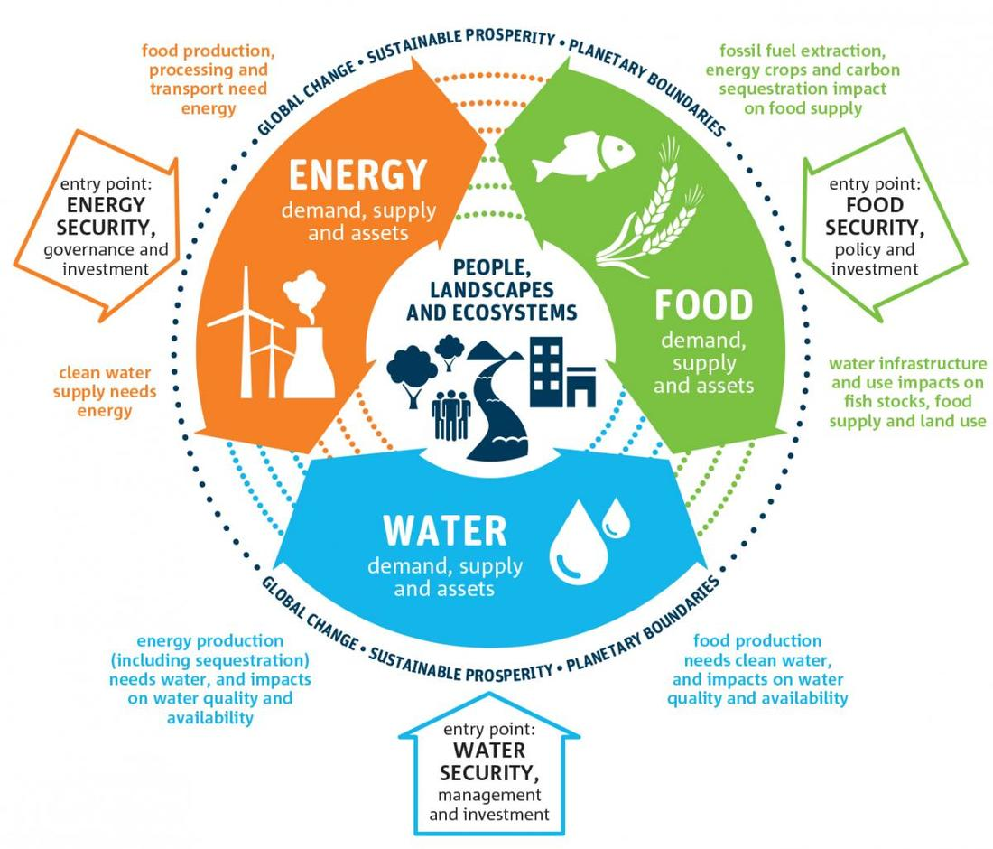
Why is the nexus important?

Water | Connections to food | Connections to energy
Water security is:

Safe water is:

Food | Connections to energy | Connections to water
Food security is:

Food availability is:

Energy | Connections to water | Connections to food
Energy security is:

Energy pathways are:

Geopolitical issues are:

