Nexus: Climate Change Impacts
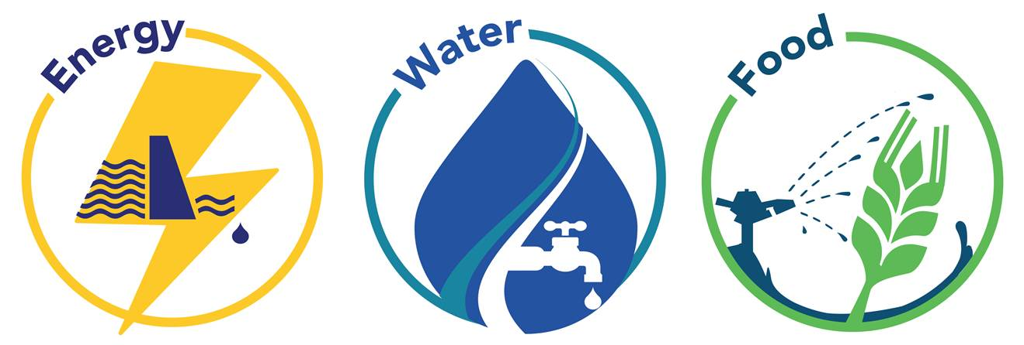
Syllabus Link: The implications of climate change for the water-food-energy nexus
- Detailed examples of two countries with contrasting levels of resource security
Take notes from the introduction on general impacts of climate change on the nexus resources
Why is nexus thinking important in adapting to climate change?

For each of the 3 nexus resources:
- Identify how climate change will impact that resource
- Make connections on how that change will impact the other resources

Water | Connections to food | Connections to energy

Food | Connections to energy | Connections to water

Energy | Connections to water | Connections to food

