Migration or Natural Increase?
A city grows through natural increase—the excess of births over deaths—and because the in-migration of people from other cities, rural areas, or countries is greater than out-migration. More developed and less developed countries of the world differ not only in the percent living in cities, but also in the way in which urbanization is occurring.
During the 19th and early 20th centuries, urbanization resulted from and contributed to industrialization. New job opportunities in the cities spurred the mass movement of surplus population away from the countryside. At the same time, migrants provided cheap, plentiful labour for the emerging factories. While the proportion increased through rural to urban migration, high death rates in the cities slowed urban growth. Cities were unhealthy places because of crowded living conditions, the prevalence of contagious diseases, and the lack of sanitation. Until the mid-1800s, the number of deaths exceeded births in many large European cities. Migration accounted for as much as 90 percent of city growth during this period.
Urbanization in most less developed countries in the past 50 years contrasts sharply with the experience of the more developed countries. Death rates have fallen faster in urban areas because of greater access to health services. Because birth rates are relatively high in most less developed countries, the rates of natural increase are also quite high in cities. Migration also fuels urban growth in less developed countries as people leave the countryside in search of better jobs.

Growth of Urban Agglomerations, 1950–2025
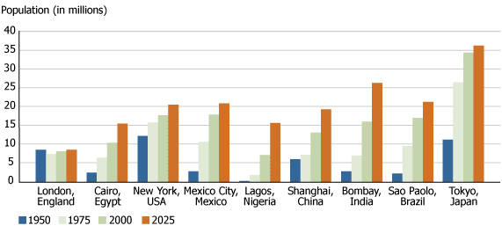
Source: United Nations, World Urbanization Prospects: The 2007 Revision.

The "Growth of Urban Agglomerations" shows population growth in selected cities. New York and London are typical of large cities in more developed countries that arose in the 1800s and early 1900s, reached their current size mid-century, and have since experienced slow growth or decline. Cities in some less developed countries, such as Mexico City, grew very rapidly between 1950 and 1980, and are growing more slowly now. Many Asian and African cities, such as Lagos and Bombay, are experiencing very rapid growth now and are projected to continue at this pace.
http://www.prb.org/Educators/TeachersGuides/HumanPopulation/Urbanization.aspx

