Mangroves: Benefits & Threats
Adapted from: http://wwf.panda.org/our_work/oceans/coasts/mangroves/
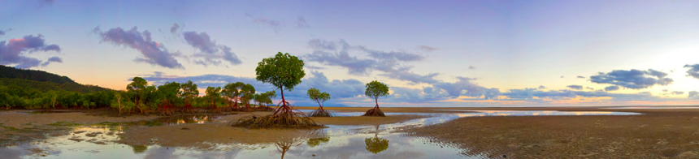

Benefits of Mangrove Forests
Like coral reefs, mangrove forests are extremely productive ecosystems that provide numerous good and services both to the marine environment and people.
According to a recent report, these goods and services are conservatively estimated to be worth US$186 million each year. They include:
- Fisheries: Mangrove forests are home to a large variety of fish, crab, shrimp, and mollusk species. These fisheries form an essential source of food for thousands of coastal communities around the world. The forests also serve as nurseries for many fish species, including coral reef fish. A study on the Mesoamerican reef, for example, showed that there are as many as 25 times more fish of some species on reefs close to mangrove areas than in areas where mangroves have been cut down. This makes mangrove forests vitally important to coral reef and commercial fisheries as well.
- Timber and plant products: Mangrove wood is resistant to rot and insects, making it extremely valuable. Many coastal and indigenous communities rely on this wood for construction material as well as for fuel. These communities also collect medicinal plants from mangrove ecosystems and use mangrove leaves as animal fodder. Recently, the forests have also been commercially harvested for pulp, wood chip, and charcoal production.
- Coastal protection: The dense root systems of mangrove forests trap sediments flowing down rivers and off the land. This helps stabilizes the coastline and prevents erosion from waves and storms. In areas where mangroves have been cleared, coastal damage from hurricanes and typhoons is much more severe. By filtering out sediments, the forests also protect coral reefs and seagrass meadows from being smothered in sediment.
- Tourism: Given the diversity of life inhabiting mangrove systems, and their proximity in many cases to other tourist attractions such as coral reefs and sandy beaches, it is perhaps surprising that only a few countries have started to tap into the tourism potential of their mangrove forests. Places as diverse as Bonaire and offer snorkelling expeditions in and around mangroves to witness a marvellous variety of baby fish, jellyfish, and urchins against a magical background of interwoven roots delving deep into the sandy substrate. Great potential exists elsewhere for revenue generation in this manner, which values the mangroves intact and as they stand.

Threats to Mangrove Forests
More than 35% of the world’s mangroves are already gone. The figure is as high as 50% in countries such as India, the Philippines, and Vietnam, while in the Americas they are being cleared at a rate faster than tropical rainforests.
Threats to mangrove forests and their habitats include:
- Clearing: Mangrove forests have often been seen as unproductive and smelly, and so cleared to make room for agricultural land, human settlements and infrastructure (such as harbours), and industrial areas. More recently, clearing for tourist developments, shrimp aquaculture, and salt farms has also taken place. This clearing is a major factor behind mangrove loss around the word.
- Overharvesting: Mangrove trees are used for firewood, construction wood, wood chip and pulp production, charcoal production, and animal fodder. While harvesting has taken place for centuries, in some parts of the world it is no longer sustainable, threatening the future of the forests.
- River changes: Dams and irrigation reduce the amount of water reaching mangrove forests, changing the salinity level of water in the forest. If salinity becomes too high, the mangroves cannot survive. Freshwater diversions can also lead to mangroves drying out. In addition, increased erosion due to land deforestation can massively increase the amount of sediment in rivers. This can overcome the mangrove forest’s filtering ability, leading to the forest being smothered.
- Overfishing: The global overfishing crisis facing the world’s oceans has effects far beyond the directly overfished population. The ecological balance of food chains and mangrove fish communities can also be altered.
- Destruction of coral reefs: Coral reefs provide the first barrier against currents and strong waves. When they are destroyed, the stronger-than-normal waves and currents reaching the coast can undermine the fine sediment in which the mangroves grow. This can prevent seedlings from taking root and wash away nutrients essential for mangrove ecosystems.
- Pollution: Fertilizers, pesticides, and other toxic man-made chemicals carried by river systems from sources upstream can kill animals living in mangrove forests, while oil pollution can smother mangrove roots and suffocate the trees.
- Climate change: Mangrove forests require stable sea levels for long-term survival. They are therefore extremely sensitive to current rising sea levels caused by global warming and climate change.

