London – Urban Case Study Introduction

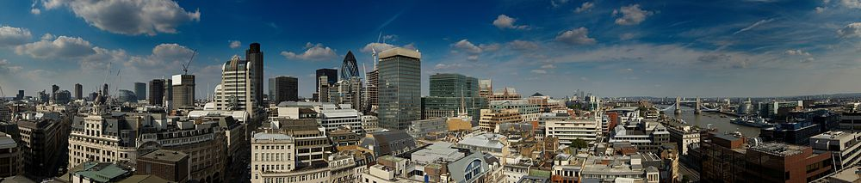

Syllabus Links: The characteristics and distribution of urban places populations and economic activities.

Population
Site features
Patterns of land use
(include a screenshot)
Function
Position in urban hierarchy
Brief history
London as a mega city

