London: The world’s most international city
June 30th 2012

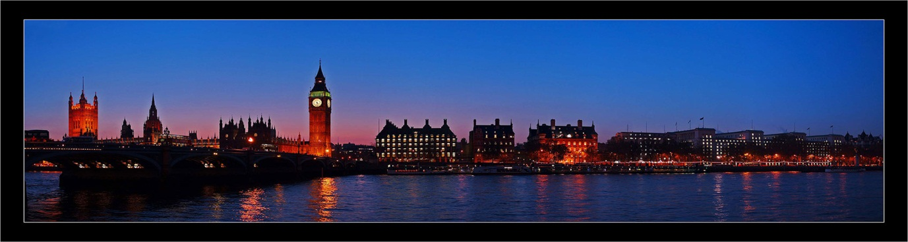

While the UK has slipped to seventh place in the league of world GDP, the capital is first, or second to New York, in most of the rankings of cities.
It wasn’t always like this. After a boom in Victorian times (1840-1900), the city went into a decline from the beginning of the World War II. Bombing, the decline of manufacturing, the closure of the docks along the river Thames and government policies designed to reduce the city’s dominance were responsible. By the late 1980s the population had shrunk by a quarter.
Then things turned around again. In the 1980s the liberalisation/deregulation of the financial services industry drew in people and money from around the world. A convenient time zone and a language which imperialism had spread around the globe made it easy for foreigners to operate in the city, too. And a trustworthy legal system made it a good place to do business.

Some come for jobs, some for sanctuary, and some for fun. London has a creative buzz that makes it feel more like New York than Paris or Rome. It has been heightened by the arrival of young foreigners escaping more conventional or oppressive societies, and coming to find themselves and each other.
Thus globalisation, concentrated in London, turned the place into the world’s most international city. New York has as many foreign-born people as London—a bit more than a third—but its businesses look to America, whereas London’s look out to the world. And whereas New York’s immigrants are mostly huddled masses, London attracts the smart professionals and the stinking rich as well. Its elite are increasingly made up of foreigners, or the children of foreigners.
For Londoners, this has a downside. Per square foot, property in London is more expensive than anywhere except Monaco. While property prices in other capitals have fallen during the economic crisis, demand for central London property from emerging markets has pushed prices in the city up still further.
There is a larger upside. Steve Varsano, a New Yorker who sells private jets, moved from America to London a couple of years ago. His showroom, which is kitted out as a luxury aircraft interior—cream leather seats, snakeskin walls, mahogany trimmings—is on Hyde Park Corner, one of the most expensive areas of the city.
To Mr Varsano, it is an unbeatable location. Fifteen years ago, he says, 70% of the world’s private jets were sold in America. These days, maybe 35-40% are. “Anybody that can afford a jet comes to London. The only bits of London they know are Belgravia, Knightsbridge and Mayfair [the areas that meet at Hyde Park Corner]. They all have to stop at that light,” he says, pointing at the traffic light on the southern side of the roundabout. “As the car swings round, the guy in the back seat has to look into my showroom. I have the best window on four continents.”
Mr Varsano is not alone in his enthusiasm for the city. Over the past quarter-century, unprecedented numbers of foreigners have come to live, work and invest in the city. Largely as a result, London has had an astonishing period of growth that has survived the recession in Britain and the economic crisis in Europe.
Partly thanks to better education, fewer Britons are leaving the city. At the same time, foreigners are still coming and, because of recent immigrants’ high fertility, the birth rate is accelerating. So the population is rising fast (see below).
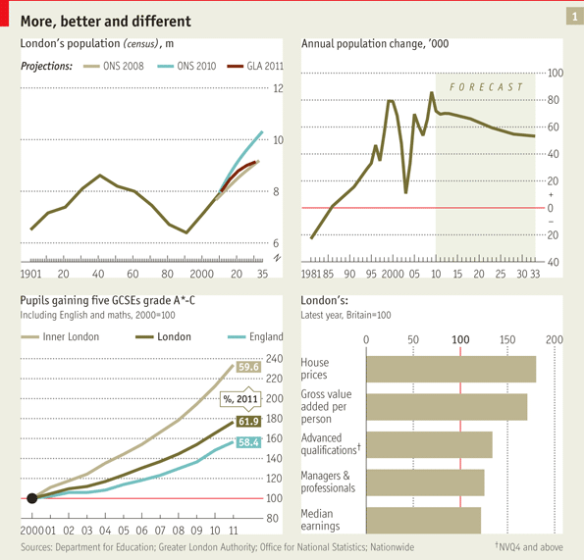
Stay open to stay great

This is a great time for London, but its moment will inevitably pass. The accumulation of capital from the empire and the industrial revolution made the place rich; and now, with the rise of the emerging markets, capital is accumulating elsewhere, particularly in Asia. Europe’s traumas will shape its future, either because it is bound more tightly into the continent, or, more likely, because it floats away from it. Yet London’s prosperity is built on its ability to attract the rich, the clever and the hard-working from all over the world. It is the UK’s economic and cultural powerhouse, Europe’s only properly global city and a magnet for rich and poor, from anywhere and everywhere.

