Life Expectancy Activities

Activity 1: Life Expectancy Patterns
Use the map below or the website http://www.worldlifeexpectancy.com/world-life-expectancy-map to describe patterns in global life expectancy.
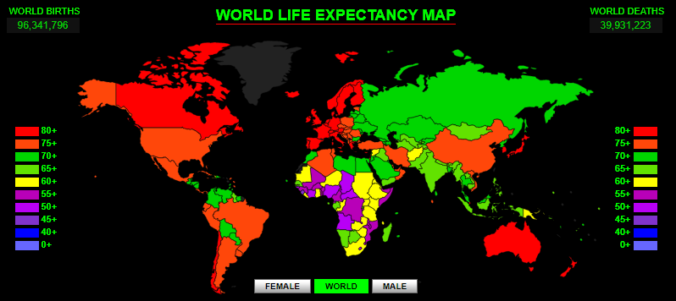

Activity 2: Life Expectancy Trends
Use this visualization http://flowingdata.com/2011/10/13/life-expectancy-changes/ to show trends in global trend of life expectancy since 1960 and then write a paragraph summarizing this in the space below.

Activity 3: Explaining patterns and trends in life expectancy
In the space below state reasons for the patterns and trends in global life expectancy since 1960.

