The ‘Leisure Hierarchy’
The availability of leisure facilities varies according to the size of the settlement. Each leisure facility is influenced by:
- Its threshold population – the number of people needed to support the facility
- Its catchment area or sphere of influence – the size of the area that the facility serves
- Its range – the maximum distance people are prepared to travel to use the facility
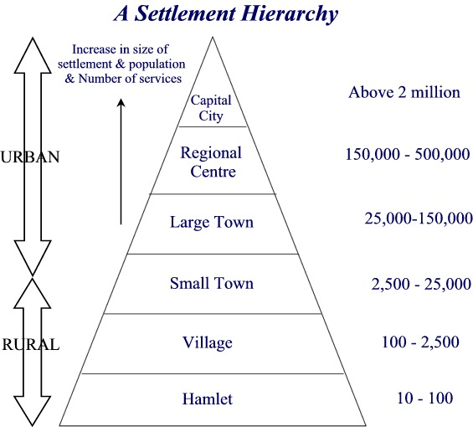
Smaller settlements offer leisure facilities that can survive on a smaller threshold population with a smaller sphere of influence and range.
Larger settlements have higher order leisure facilities/services. These include specialized services that need a large threshold population.

Activity 1
Classify the following leisure facilities according to the size of settlement in the table below:
Garden centre Leisure Centre Gym Theatre Restaurant Resort Hotel
Country Park Community Centre Museum Horse Riding Centre Local Bar
Library Hotel/Guesthouse Travel Agents Bowling Alley Nature Reserve
Nightclub Specialist Sports Shop Sports Field Cinema Post Office
Size of settlement | Leisure Facilities/Services
City
Town
Village
Hamlet

Intra-Urban Leisure Patterns
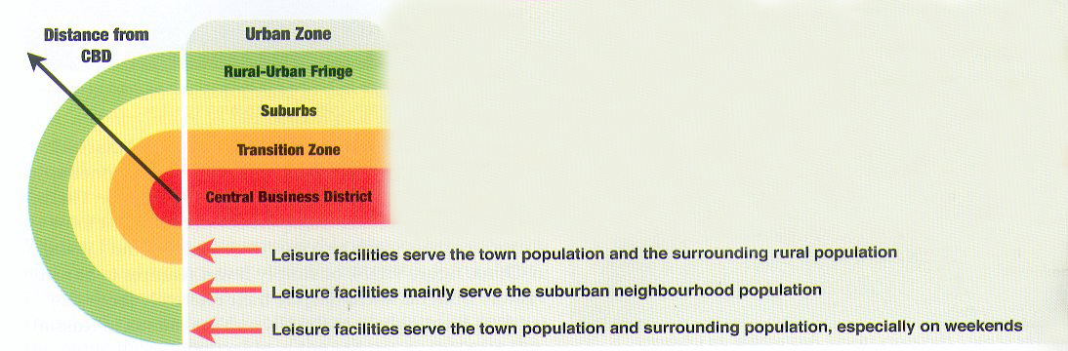
From the centre to the edge, the availability of leisure facilities varies between zones (‘intra-urban’) of a city too. This diagram shows the zones of a typical MEDC city:
Rural –Urban Fringe: The edge of the city where urban and rural land uses mix
Suburbs: A largely residential zone with larger houses with gardens
Transition Zone: A zone characterized by industry/warehouses and inner city housing, some of which has been gentrified
Central Business District: The commercial and economic core with the highest accessibility and highest land values

Activity 2
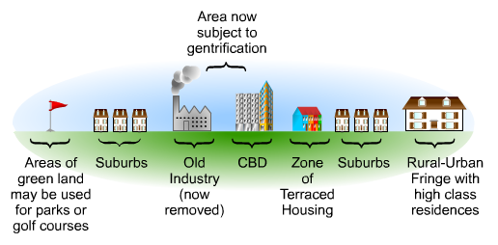
Imagine you are completing a land use transect from the Central Business District (CBD) to the Rural-Urban Fringe to record the variation in leisure facilities from the centre to the edge of the city.

As you walk from the CBD outwards, what would you expect to find and why?
Urban Zone | Leisure Facilities | Explanation
Central Business District
Transition Zone
Suburbs
Rural-Urban Fringe
Activity 3: Open Spaces in Urban Areas
Open spaces, including city parks nearer the centre and country parks on the edge of the city, are regarded as an important land use in any urban area. Give at least three reasons why it is important for city planners to ensure that there is sufficient open spaces for urban residents.

Activity 4: Applying an urban leisure hierarchy model to Bangkok:
How well does it fit?
Here is a model that shows the typical distribution of leisure facilities in an urban area according to a ‘leisure hierarchy’:
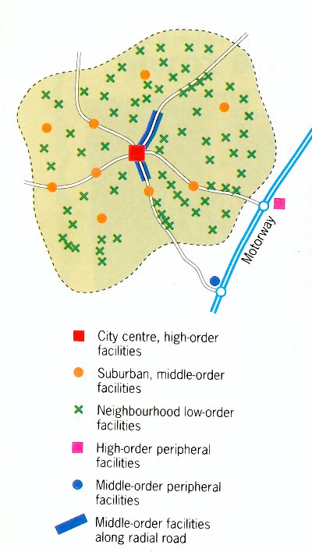

Draw an annotated sketch map of the leisure facilities in and around Bangkok.
- In your annotations, describe and explain the distribution of facilities.
You could include the following leisure facilities in Bangkok:
Golf courses Muay Thai Arena’s Shopping Centres Parks Night Clubs
Horse racing Creative Arts/Music School Pubs, bars & restaurants Water Sports
Movie Theatres Shopping Market Temples Night Markets Hotels
Massage Parlours Fishing Ponds Spots Clubs Zoos/Safaris Amusement Parks
Use the links to interactive maps on the Internal Assessment wiki to help you!

- How well does Bangkok’s distribution of leisure facilities fit the model above?
Constructing an annotated map takes some skill, although you do not have to be artistic. Make sure all your annotations are clearly linked by arrows to your map. Using a key to classify different zones on your map is a good idea too. Have a look at this example of an annotated map to explain population distribution in Brazil:
