Legacy, what legacy? Five years on the London Olympic park battle still rages
Thursday 27 July 2017
The media, the sporting fraternity and politicians of all stripes celebrated the coming regeneration of the forgotten East End due to the planned Olympic Games. Meanwhile, academics, urbanists and local activists bemoaned the speed at which a patch of east London was transformed, resulting in compulsory purchase orders and displaced businesses.
The story didn’t end once the Games were finished: the battle for the Olympic legacy is a hard-fought one. The architects and developers want you to know that the area has been revitalised. The housing campaigners want you to know it has largely been revitalised for a new, wealthier demographic. West Ham United plc want you to know the London stadium will make them a top club.
So which narrative is correct? The Queen Elizabeth Olympic Park is managed as a private site by the London Legacy Development Corporation (LLDC), established in 2012, while the former athletes’ village, now known as East Village, contains the public spaces Victory Park and Mirabelle Gardens. But is the area a success or failure? And who wins the legacy medal?
As ever, it depends on who you are – and whether you see the Olympic Park as …

… a city from scratch
Ken Livingstone, then the mayor of London, said “I didn’t bid for the Olympics because I wanted three weeks of sport,” he said in 2008. “I bid for the Olympics because it’s the only way to get the billions of pounds out of the government to develop the East End – to clean the soil, put in the infrastructure and build the housing.”
Yet it’s easy to forget that what many people talk of as the benefits of the 2012 Games – new rail links and roads, Westfield shopping centre and the rejuvenation of a brownfield site – was going to happen anyway, as part of the Stratford City project that came out of the high-speed rail development to St Pancras that has also led to a regenerated King’s Cross.
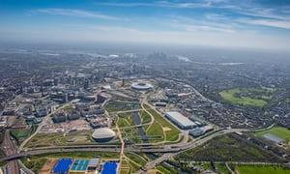

The Queen Elizabeth Olympic Park seen from 3,000ft last year. Photograph: Jason Hawkes/Barcroft Images

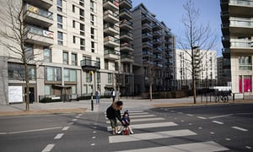
A year ago, Ramsey, head planner for the Stratford City project, went for a wander around the East Village residential development. “People love living there. They have very tight management system that makes sure the communal areas are kept nice, and security guys who go around all the time to make sure there’s no anti-social behaviour.” She speaks approvingly of a “three strikes and you’re out” system for policing antisocial behaviour. “There was only one family that they’d said had to go,” she says, proudly.
Campaigners, however, say the affordable housing targets set for the residential developments in the Olympic Park have been revised down.

… a place to live
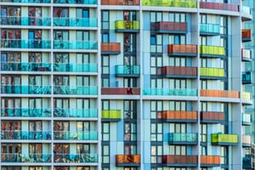
Consent was given to build 2,818 homes before the Games, with 1,379 falling into the “affordable” category. They are comprised of social rent properties that went to people from Newham and other east London boroughs, discount market rent and shared ownership properties. The remaining 1,439 are rented privately by Get Living London, owned by Qatari Diar.

New residents said, “at first it was quiet, but things have picked up,” says Philbey. “It feels like its own community, everyone is very friendly. Although you are still living in London, it feels like you are not. There are green areas where I take the kids to run around. The shopping mall is on your doorstep, there’s the health centre, and central London is only 15 or 20 minutes by train. It’s a real diverse group of people. A lot of families with children. Quite a lot of young people but there are some old people, too.”

… a place to be evicted from
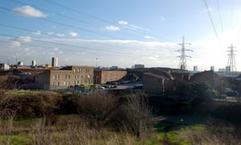

Clays Lane was the largest residential co-operative of its kind in Europe, housing 450 tenants. Julian Cheyne lived there from 1991 until it was compulsorily purchased and demolished for the Games in 2007. He and his neighbours had become accustomed to threats. “The weekend after I moved into Clays Lane in 1991, a plan came through the letterbox which said it was going to be demolished. There were always people coming up with plans on a regular basis.”
Cheyne says residents were misled over money they were entitled to, and charged too much upon leaving. “Some people had £2,000 taken off them. On what grounds? They said ‘Oh, expenses, we did a service for them’ – £2,000 worth of services?” Cheyne and some of his former neighbours had to go into emergency accommodation while waiting to be rehoused. Some residents were moved outside east London: Peabody had properties in Westminster, so some were housed there, where rent was a lot more expensive. Cheyne was rehoused in east London but says his rent is more than double what it was in Clays Lane.

… or as a place for recreation
One resident says the Olympic park space was a godsend when he was on paternity leave. “It meant I could go on a two-hour walk, feed my son in the park, there was space to move and it was easy to push a buggy around or for him to walk.” What of the criticism that the development feels alien to the surrounding area? “I disagree. The first year that it opened it felt unimpressive – the trees had just been planted, it was quite bare and scrappy and there was a lot of building work – but year on year, as the park beds in naturally, it is getting better. People go to the pool, the Copper Box gym, the Velodrome and other facilities for recreation. It feels to me that it’s used.”
Some of the Olympic Park is already threatening to fray here and there; yet it still gives off an air of newness: impersonal but with free wifi. From the comfortable charity coffee shop to the private security guards ushering you this way or that when events are on, the managed nature of the place seems to be its defining legacy.

Edited from: https://www.theguardian.com/cities/2017/jul/27/london-olympic-park-success-five-years-depends

