Japan’s Ageing Population Issue

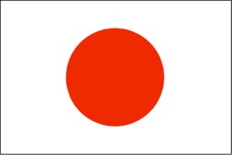

- What are the causes of Japan’s ageing population crisis?

- SEEP Analysis: What are the likely consequences of Japan’s ageing population?

Social: | Economic:
Environmental: | Political:
- Evaluate the steps the Japanese government are taking (or not taking!) to resolve this population challenge:

