Importance of Tourism: Facts & Figures Activity

Tourist numbers
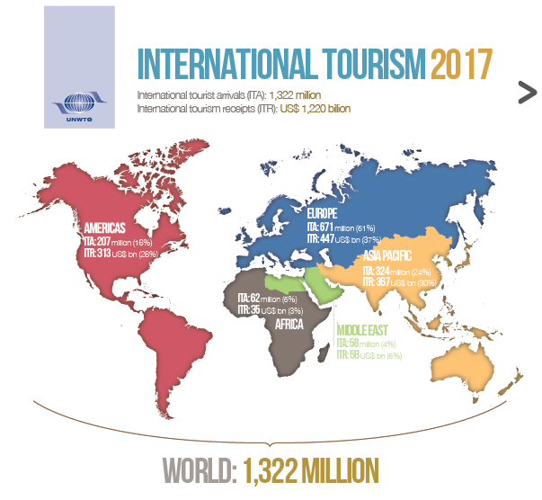
State the number of international tourists in 2017.
Trends in Tourist Numbers
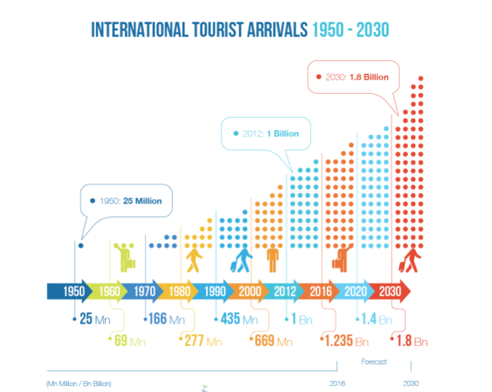
Describe the trend in international tourists arrivals from 1950-2016.
Explain why international tourism is projected to increase to1.8 billion visitors by the year 2030.
International Tourism Revenue
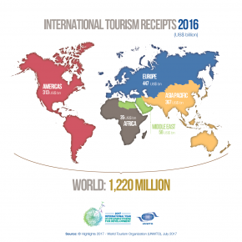
State much money was generated by international tourism in 2016
Rank by region the amount of money earned by tourism in 2016
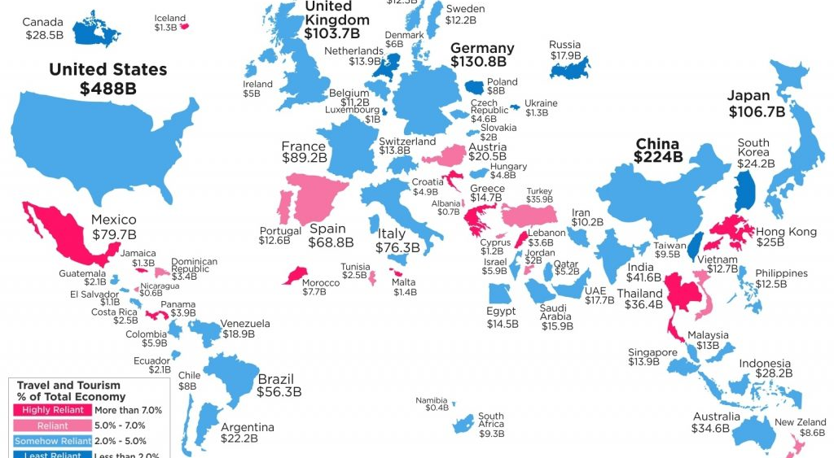
List 5 countries in which tourism accounts for over 7% of total GDP
Regional Tourism
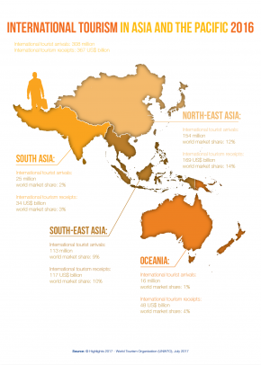
Explain why tourism is significant for South East Asia
Summary
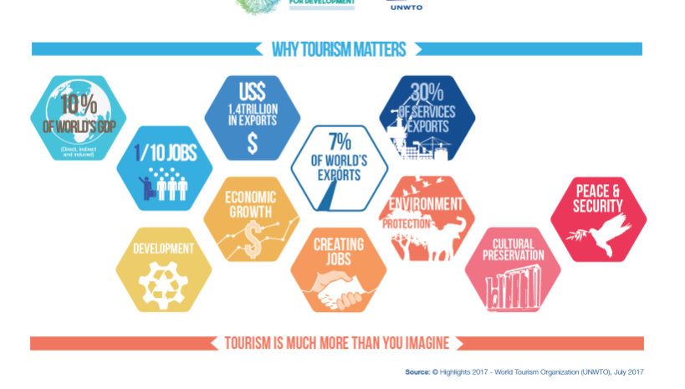
Explain why tourism is an important global industry
Source of images: http://media.unwto.org/content/infographics

