Infographic Analysis Practice #1

Infographic 1:

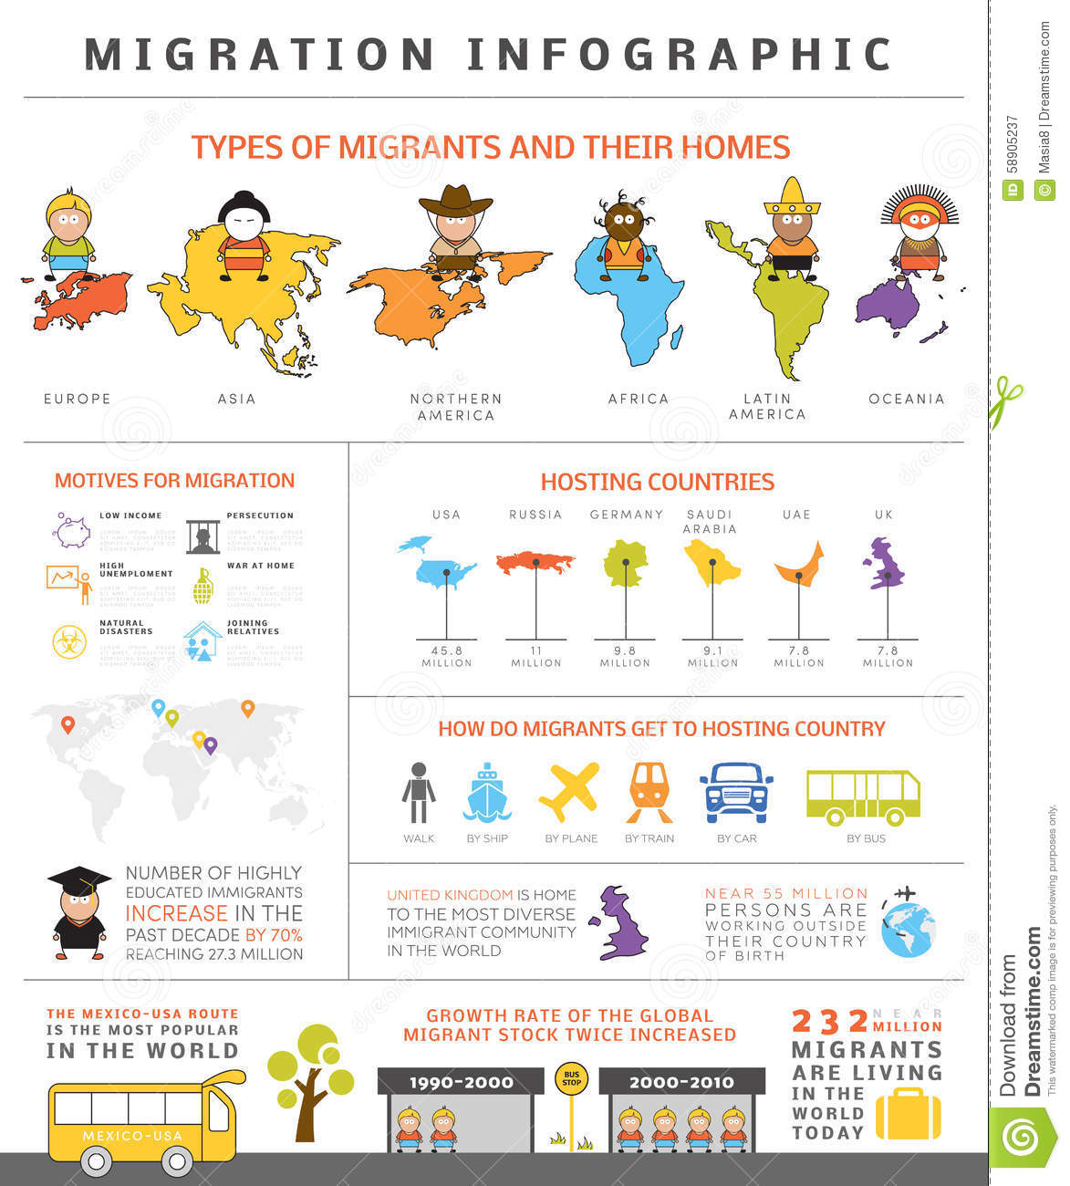

Infographic name
Type
Purpose: what is it communicating?
In what ways does the infographic portray migration negatively?
 | Strengths | Weaknesses
Information/ data
Design
Suggested improvements

Infographic 2:

Infographic name
Type
Purpose: what is it communicating?
Which region has the greatest projected life expectancy for females?
Which region has the greatest % of people over 60yrs living alone?
 | Strengths | Weaknesses
Information/ data
Design
Suggested improvements

