Hurricane Case Study-Typhoon Haiyan

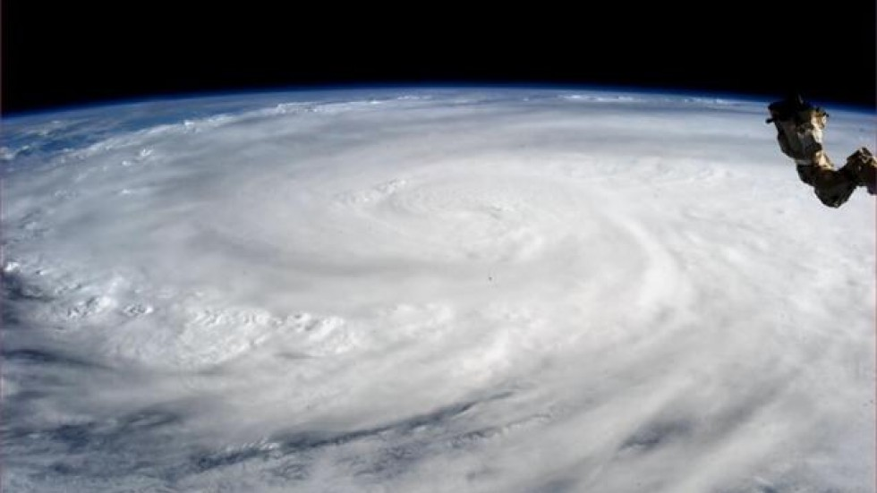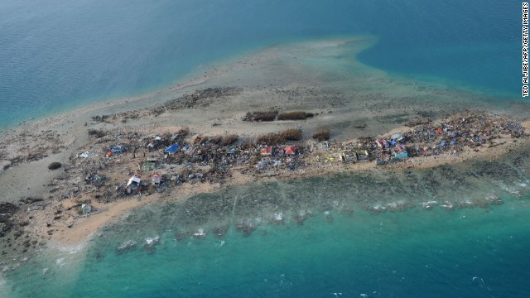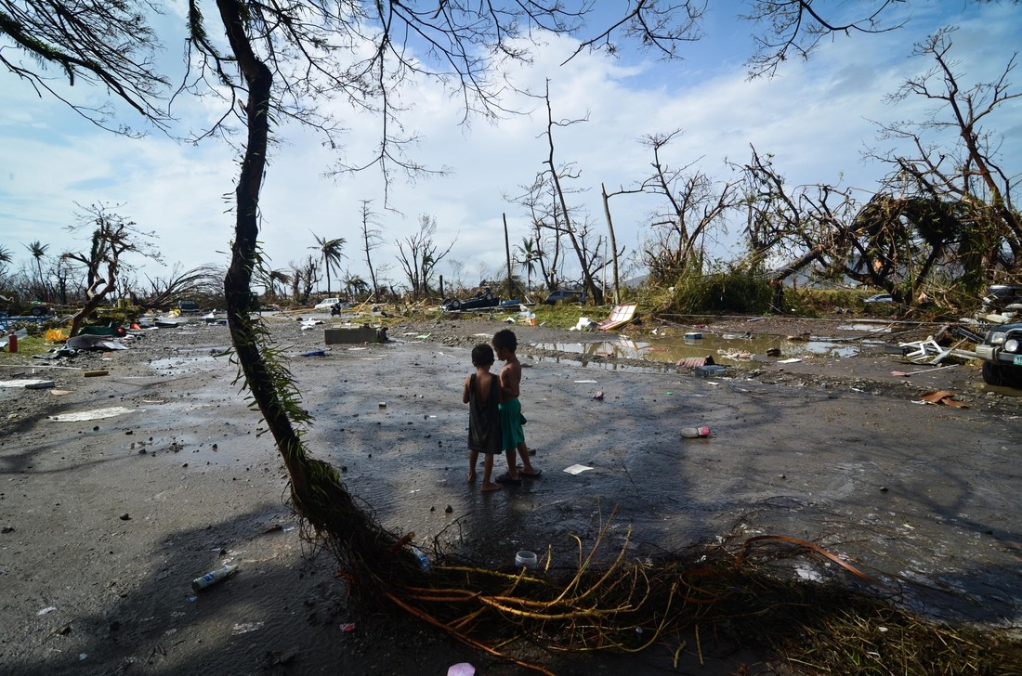

Syllabus Link
Case study of one hurricane and its impacts on coastal places and people

Hurricane Basics: Take notes on the basics of Typhoon Hai Yan
When:
Intensity:
Track and duration:
Countries impacted:
What were the impacts of Tyhoon Haiyan?
Environmental impacts | Human impacts
What was the most destructive feature of the typhoon?
Paragraph practice: Summarise the causes and consequences of typhoon Haiyan

