How a Superhero Learns to Fly
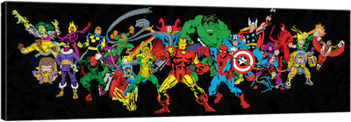

Superhero & Video Link |  | Unique Powers |  | Motivations |  | Positive Impact
Black Panther
https://www.youtube.com/
watch?v=xjDjIWPwcPU
Wonder woman
https://www.youtube.com/
watch?v=VSB4wGIdDwo
Spider man
https://www.youtube.com/
watch?v=O7zvehDxttM

Batman
https://www.youtube.com/
watch?v=neY2xVmOfUM
Ghandi
https://www.youtube.com/
watch?v=4pENM42-QB8

Martin Luther King
https://www.youtube.com/
watch?v=r6_AbP7v9nI

Summary | Unique Powers |  | Motivations |  | Positive Impact
Fictional super heros

Human super heros

Describe the differences between the fictional and real super heros
Describe the similarities between the fictional and real super heros
In your opinion what makes a superhero learn to fly?
