Getting to Know Ko Samet Homework
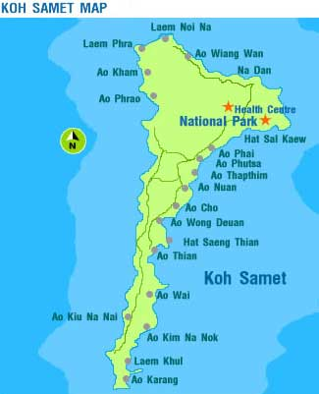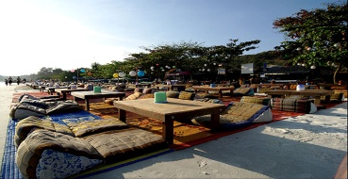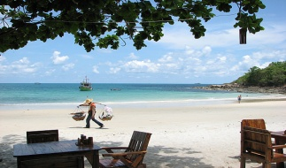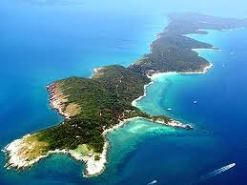
Introduction:
Rationale: Your geography internal assessments will be based on investigating tourism on Ko Samet. You will use Butler’s model of the life cycle of a tourism resort to evaluate where Ko Samet currently lies in terms of tourist development. It is therefore essential that you become as knowledgeable as possible about aspects of tourism on the island and Butlers model.
Task: You need to research tourism on Ko Samet and then use google screenshots to apply Butler’s model. You will make a word or google doc document that introduces Ko Samet and uses google earth to analyze the current stage of development for some beaches. Notes you create in the process should be ongoing and continually added to when you find new information.
Sources of Information: For Ko Samet information you will need to do some internet research. You have been given a comprehensive handout on Butler’s model some of which comes from this site http://www.numptynerd.net/tourism-the-butler-model.html
Idea – You are strongly encouraged to start an ongoing bibliography of any sources you use and keep it as a word document that can be part of your actual internal assessment. Any notes you make will be useful for your IA.

Ko Samet Background:
The more you know about Ko Samet before you go on the fieldtrip the better chance you have of producing a good investigation. It is suggested you make notes on the points below:
- Location (it would be helpful to save links etc to maps)
- The natural environment and the island’s status as a national park
- Attractions (primary and secondary)
- Background of tourism on the island
- Visitor numbers
- Statistics: make a note of any useful statistics that you find related to Ko Samet – tourist numbers, land values, etc.
- Visuals: relevant images, graphs etc

Google Earth Investigation:
You need to use google earth to examine the level of development of tourism on Ko Samet. To do this you should:
- Find Ko Samet on google earth or maps and take a screenshot of the whole island
- Locate and screenshot the following beaches:
  - Sai Keaw
  - Ao Prao
  - Ao Vong Duan
  - Ao Nuan
- Use terminology from Butler’s model to comment on the current stage of tourism development on each of those beaches. Try to use analytical language, eg, “The high number of buildings on the beach indicate that it is at the consolidation stage of development” or “There are a large number of boats at the beach indicating easy accessibility and suggesting this beach is in the development stage”.

Due Date: Tuesday 6th March

Final Comment:
We can’t reiterate strongly enough how important it is to be as knowledgeable on tourism, Ko Samet, and Butler’s model as possible before we go on the fieldtrip. The IA from the fieldtrip will be 20% of your final geography grade for HL and 25% for SL.

