Geography of a National Sports League
Syllabus Link: Factors affecting the geography of a national sports league, including the location of its hierarchy of teams and the distribution of supporters
• Case study of one national sports league
Team locations
Locate the current 20 EPL teams on the map below
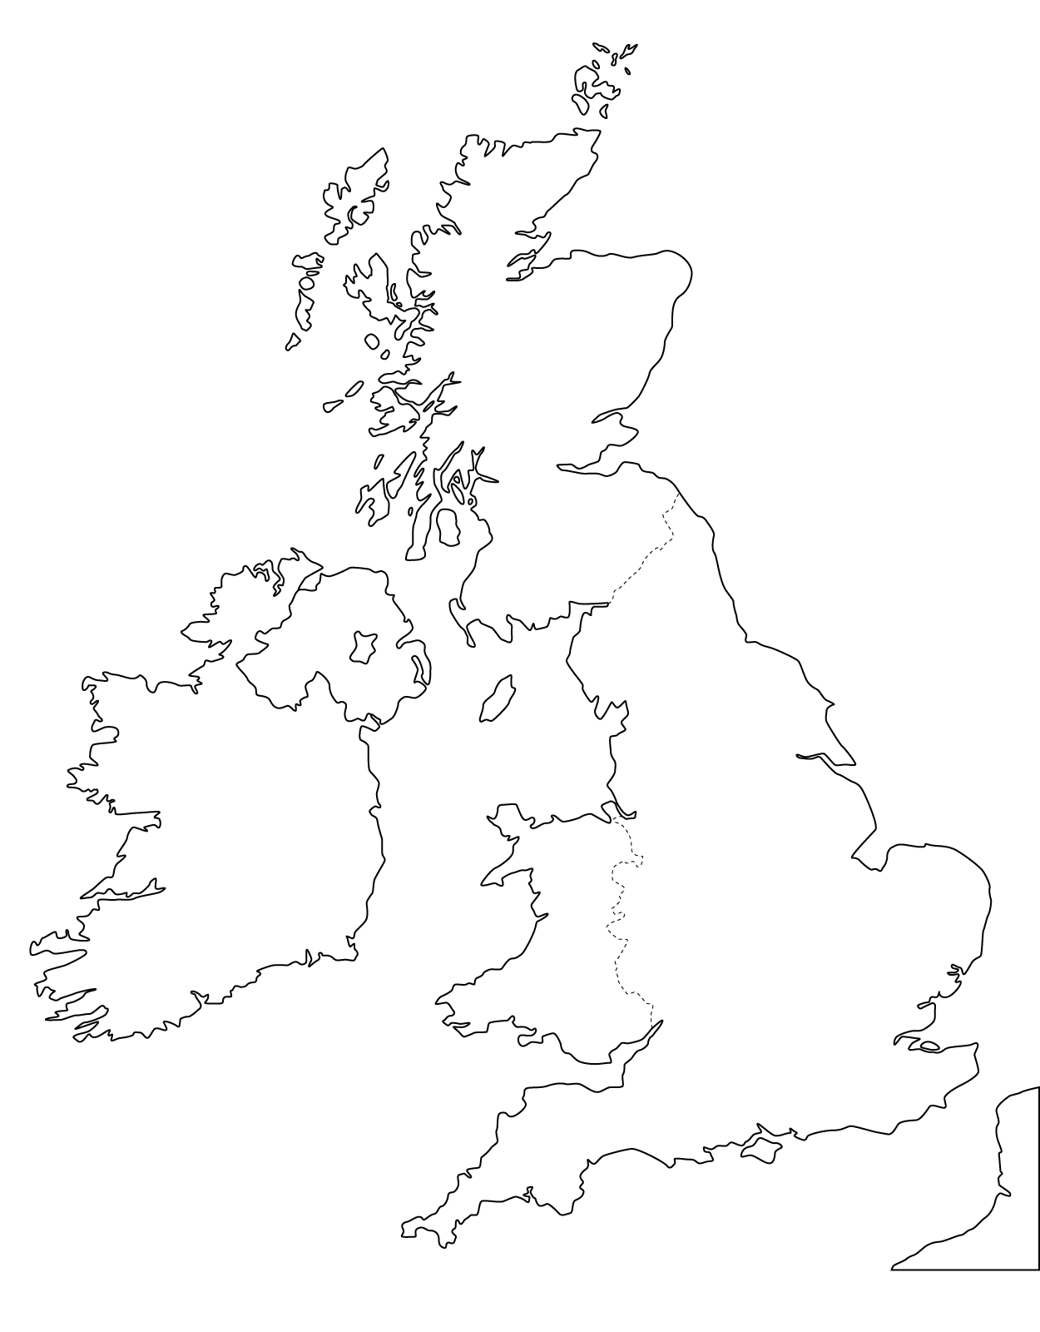
Describe the location of and the spread of EPL teams in England. Comment on any patterns and give possible reasons to describe where the teams are located.

Hierarchy of teams
Go to the following web links and make a note of the champions, runner up and third placed finisher for the last 5 seasons https://en.wikipedia.org/wiki/List_of_English_football_champions
Year | 1st | 2nd | 3rd
2017
2016
2015
2014
2013
Use the same link to list teams that have won the EPL (and add the number of times they have won it)
Describe and explain the hierarchy in the premier league in comparison to location

Location of Supporters
Go to the following link and add in the average attendance figure for the top and bottom 4 EPL teams for the 2016/17 season https://www.statista.com/statistics/268576/clubs-of-the-english-premier-league-by-average-attendance/
Top Clubs | Bottom Clubs
Explain the relationship between crowd size and success in the EPL
Look at the graph below and describe any obvious patterns to how far supporters travel to support their team
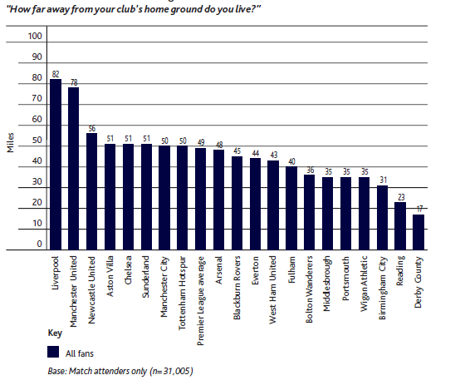
Use this link to see the level of overseas support for EPL teams https://interactive.twitter.com/premierleague/#?mode=team&teamId=all and comment on patterns.

