Geography IA Mark Scheme!

Criterion A: Fieldwork question and geographic context:
The fieldwork question (the precise inquiry) guides the fieldwork investigation. It must be focused, appropriate and stated as a question that can be answered through the collection of primary information in the field. Where appropriate, students can make a brief preliminary judgment or prediction answering the fieldwork question. This prediction may be formulated as a hypothesis.
Students must also comment briefly on the geographic context, explaining why and where the fieldwork investigation is to be carried out. This can include relevant spatial, physical, socio-economic conditions and other background information, concepts or characteristics. A map of the research area and/or the locations used in the fieldwork investigation is essential to provide the necessary spatial element.
Students must also state the area(s) of the syllabus to which the study relates, which geographic inquiry topic or sub-topic in the syllabus, whether it is from the optional themes, the core theme, or the HL extension. It can be drawn from a combination of two or more topics or themes.
This criterion assesses the focus and geographic context of the fieldwork and to what extent the link between the fieldwork question and the geographic context (that is, material in the syllabus, a relevant syllabus topic or geographical theory) is made clear. The fieldwork question should be specifically geographical.
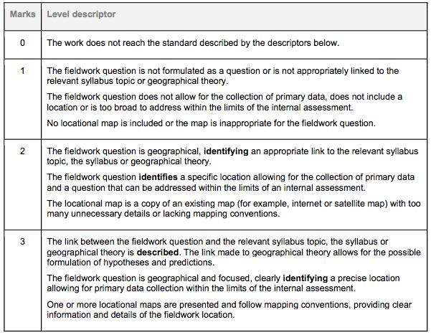Criterion B: Method(s) of investigation
Students must describe the method(s) used to collect information. The description may include technologies employed, sampling techniques, time, location and circumstances of information collection where relevant.
The method(s) used must be justified and must enable a sufficient quality and quantity of primary data to be produced to allow the fieldwork question to be investigated.
This criterion assesses the description, justification and appropriateness of the method or methods including sampling and surveying techniques, primary or secondary data collection as appropriate used to investigate the question formulated.
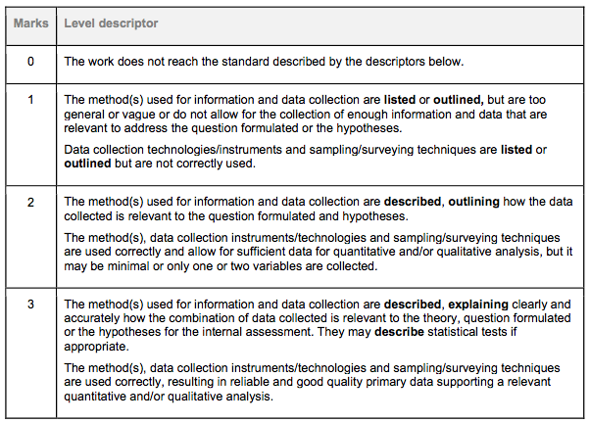
Criterion C: Quality and treatment of information collected
Students should treat and display the information collected using the most appropriate techniques. These techniques must be the most effective way of representing the type of information collected and must be well used. The precise techniques employed will differ depending on the nature of the fieldwork question but may include statistical tests (including confidence limits), graphs, diagrams, maps, annotated photographs and images, matrices and field sketches.
Students must also refer to the geographic context, information collected and the ways in which the material has been treated and presented.
This criterion assesses the quality of information and data collected and its suitability for analysis in criterion D, whether it is appropriate and a sufficient range of techniques have been used for the presentation of information, and whether the presentation follows accepted conventions (that is, the numbering, labelling, and annotating of tables, graphs and diagrams).
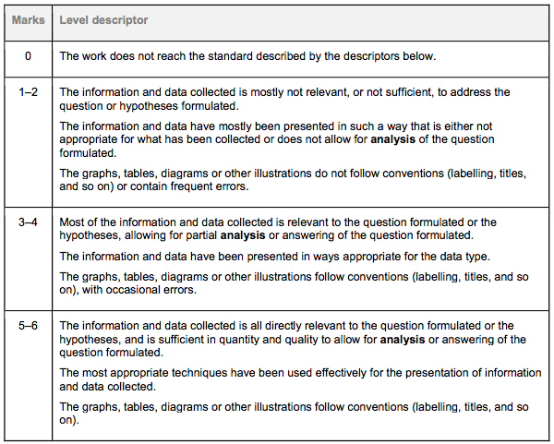
Criterion D: Written analysis
In the written analysis, students must demonstrate their knowledge and understanding of the fieldwork investigation by interpreting and explaining the information they have collected in relation to the fieldwork question. This includes recognizing any trends and spatial patterns found in the information collected. Where appropriate, an attempt should be made to identify and explain any anomalies.
The treatment and display of material and the written analysis must be integrated within this section.
This criterion assesses the quality of the analysis of the results, referring to:
- links to the question and hypotheses formulated
- geographic context (that is, geographical theory, the syllabus, or the relevant syllabus topic)
- information collected
- statistics used (descriptive techniques—that is, graphs, charts, histograms and so on; as well as statistical techniques—that is, correlations, regression and so on)
- illustrative material.
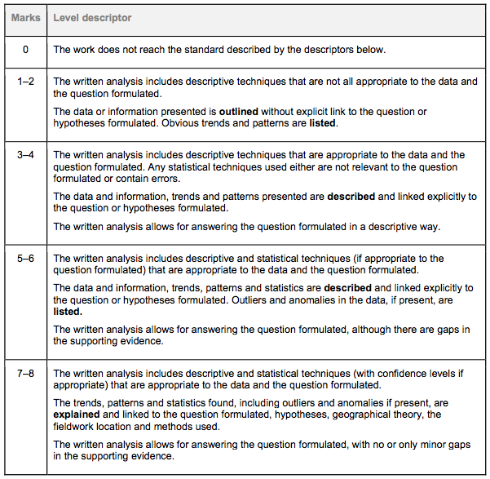

Criterion E: Conclusion
Students should summarize the findings of the fieldwork investigation. There should be a clear, concise statement answering the fieldwork question. It is acceptable for the conclusion to state that the findings do not match the student’s preliminary judgment or prediction.
This criterion assesses the ability of the student to summarize the findings of the fieldwork investigation and draw a supported conclusion.
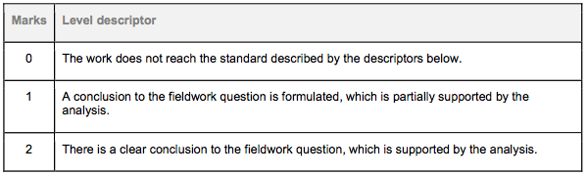
Criterion F: Evaluation
Students should review their investigative methodology, including methods of collecting primary information. Within this, they should consider any factors that may have affected the validity of the data, including personal bias and unpredicted external circumstances such as the weather.
Students should suggest specific and plausible ways in which the study might have been improved and could be extended in the future.
This criterion assesses the student’s ability to review the investigative methodology, by weighing up the strengths and/or weaknesses of the chosen method, and suggest improvements.
