Geography IA: Steps for Success
Investigate and get to know Ko Samet
- Describe attractions and reasons it is a hotspot
- Find visitor numbers and types and highlight how tourism development has evolved on the island
- Consider why it may be a good location to analyze tourism using Butler’s model
- Make use of Google earth or maps to get to know the island
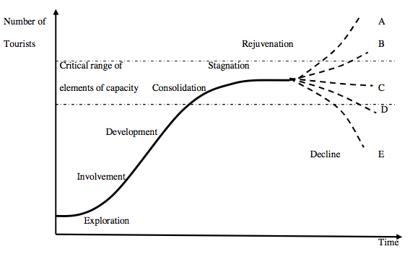 | Learn about Butler’s Model  - Get to know the stages well  - Determine factors that indicate which stage of the model a place is and incorporate this into your methodology  - Link it to the geography syllabus  - Refer back to it constantly in your analysis
Plan your methodology
- Determine what are the important aspects of tourism development and of Butler’s model that could apply to Ko Samet
- Design surveys to ensure you collect the correct qualitative data
- Plan techniques to collect the quantitative data you need and ensure you have all required equipment, surveys and base maps etc before you leave
Work as a team to collect your data
- Work as a team throughout the trip
- Do as much fieldwork as you can when there
- Process your data as much as possible on the trip
- Make sure all the information you collect is secure and shared
Use your time on Ko Samet wisely
- Do as much fieldwork as you can on the trip
- Reflect on your first data collecting opportunities and modify techniques if needed
- Make the most of evening sessions to try to complete at least your intro, methodology, and evaluation while on Ko Samet
Process your data
As a group
- Process your surveys to get raw data totals
Individually
- Process your data to show patterns and trends
- Try to use statistical techniques if possible
Create visuals
- Use tools such as Excel, Pixlr Editor, Piktochart, Google Earth, Google Draw, etc
- Create a variety of visuals including annotated photos
- Ensure that you include some spatial mapping

Get analytical
- Refer specifically to the patterns/ trends displayed in your visuals
- Use formal analytical language
- Recognize and account for any anomalies
- Ensure all of your analysis links back to the research question and relates to Butler’s model

Produce your final draft
- Structure your report as required and follow all required conventions for formatting, layout and referencing
- Ensure you stay within the 2500 word limit
- Edit it fully before you hand it in
- Important: Your final draft should be what you consider to be the finished IA
Reflect on advice and produce final version
- Pay attention to all advice offered as feedback
- Act on feedback as quickly as possible
- Make use of the IA final checklist
- Ensure you hand it in on or before the due date

