Gentrification in Post-industrial Cities
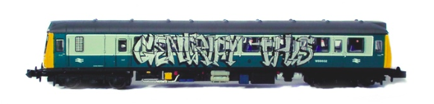

Gentrification is:

Case Studies: watch the following vides and take notes
Seoul
Bangkok
Paris
London

Questions

- What type of movement is gentrification?

- Who moves and where?

- Outline the process by which areas become gentrified.

- With reference to key terms and the concept of power, describe the impacts of gentrification on both the existing population and the new population.

- Distinguish between re-urbanisation and gentrification.

